The Bridgeview Care Coordinator User Guide has been updated and will be posted to the Care Coordination website. The most recent changes are in red font for easy identification. The following are a few highlights:
Bridgeview Care Coordination User Guide Updates

- Care Coordinator Information screen—new screenshot showing Blue Plus cut-off dates for EW reassessments. This was added as another reminder of cut-off dates as also listed in the Care Coordination Guidelines for Community.

- Transfer FNU instructions and new screenshots:
  - Definition of TRANSFER FNU added to the grid of HRA Form Used drop-down options. With a reminder the date of FNU should not be used to calculate the next reassessment.
  - Transitional HRA section was retitled to Transitional HRA/Transfer FNU
  - Users will receive an edit if the Fee-For-Service/Reviewed HRA is not entered prior to the Transitional HRA or Transfer FNU.
  - HRA Audit process related to Transfer FNU—no documentation needed (auditor will review in the MnCHOICES application).
- CDCS Legislative Rate Changes and/or approving unallocated funds through Plan Addendum—UPDATED PROCESS.
After completion of the DHS 6633A AND/OR approving a Plan Addendum, the Care Coordinator must also do the following to Modify current CDCS T2028 span.

- Select the T2028 authorization you would like to modify and select view.

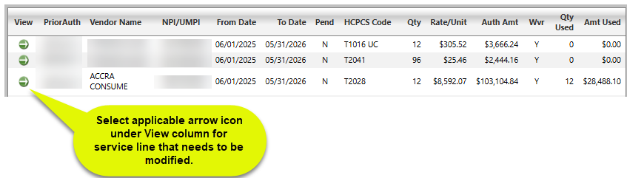

- Select Modify
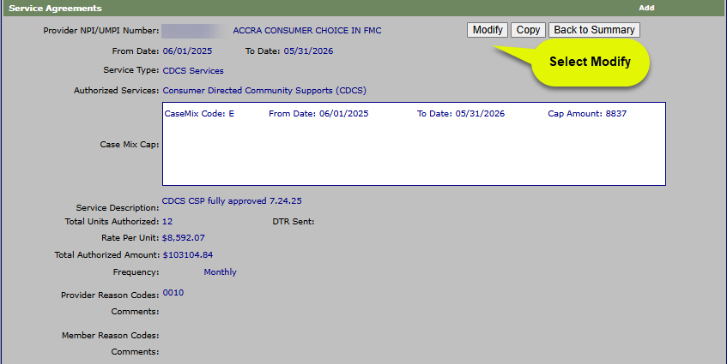

- Regarding the T2028 CDCS Service Agreement, you will modify:
    - To Date: Only change the date if the authorization is ending early.
    - Service Description: add the CDCS addendum NEW approved amount with date addendum reviewed/approved OR note the reduction amount
    - Total Units Authorized: Only change if changing the To Date
Note:
- The new approved CDCS amount must not be more than the EW Case Mix amount.
- Complete a DTR even if the reduction and addendum are based on the member's choice.
- If you change the To Date and units authorized, you must select Yes or No for DTR.
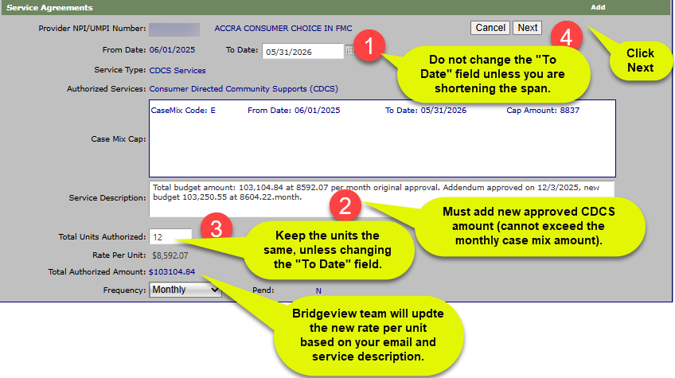

- Contact Bridgeview.service.agreements@bluecrossmn.com informing them of what is being requested of them. Include the following:
- Member Name.
- Subscriber ID number.
- Bridgeview staff will do the following:
- Modify the original Service Agreement
- Add a new monthly rate amount that includes the increase/decrease provided in the Service Description

- Community First Services and Supports (CFSS) Services Agreements

  - Section for brand new to CFSS (did not previously have PCA)
  - CFSS Consultation Service Agreement
  - CFSS Agency Training and Development Service Agreements
  - CFSS Agency and Budget Services—PERS and Goods and Services Service Agreements
  - CFSS 45-Day Temporary Start Service Agreements
- PCA to CFSS Transition Period Service Agreements—process for entering existing members with PCA and choosing either Agency or Budget Model.
- Home Health Aide and Skilled Nurse Visit Service Agreement—For both sections, when selecting “Request for Review” in the drop-down status, the User must include the contact person for the home care provider in the Service Description so UM team can request the CMS-485.
- Adding a New Service Agreement (general process)—For all authorizations using 15-minute unit increments, the Service Description must include a reference to the number of 15-minute units per day and per week (except for PCA Supervision).

