2026 SecureBlue MSHO Annual Supplemental Benefits webinar training
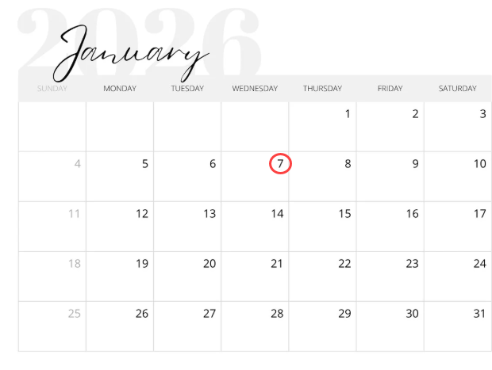
You are invited to our Blue Plus 2026 SecureBlue MSHO Annual Supplemental Benefits webinar training.
This training will include presentations from our SecureBlue MSHO Supplemental Benefits providers.

Date: January 7, 2026
Time: 10AM – 11:30AM

Microsoft Teams Need help?
Join the meeting now
Meeting ID: 213 774 342 023 61
Passcode: ss25XR62
Dial in by phone
+1 651-724-9390,,186799682# United States, Minneapolis
Find a local number
Phone conference ID: 186 799 682#

NOTE: This webinar training will be recorded and posted to our care coordination website.

