Legislative Rate & Case Mix Budget Increases Effective 1/1/2026
Effective January 1st 2026, DHS will implement the following rate and budget increases:
- 6.013% increase to EW monthly case-mix budget caps.
- 6.013% increase to consumer-directed community supports (CDCS) budgets
- 6.013% increase to EW 24-hour customized living daily and monthly limits. This change will happen on a rolling basis as lead agencies renew service plans throughout the year.
- 6.34% increase in home-delivered meals.
- 2.7% increase to environmental accessibility adaptations (EAA).
- State Plan Home Care:
  - 3.19% increase in home health aide, skilled nursing, occupational therapy, physical therapy, respiratory therapy, and speech therapy (market basket adjustment).
  - The same percentage increases also apply to extended home care services.
- PCA/CFSS rate increases include changes to the wage component value and implementation factor within the PCA/CFSS rate framework:
  - .13% increase to 1:1 PCA/CFSS, PCA supervision and CFSS worker training and development.
  - 4.79% increase to PCA/CFSS complex.
  - The same percentage increases also apply to extended PCA/CFSS.

For more information, refer to the DHS 3945 Long Term Services and Supports Service Rate Limits and the DHS announcement on Long-term services and support rate changes.

Bridgeview auto-updates:
On Saturday, December 20th, Bridgeview staff will automatically split and update all service agreements that are subject to the rate changes for 1/1/2026, except for 24-hour Customized Living and CDCS.
- Care Coordinators should review service agreements for accuracy and update the MnCHOICES Support Plan to ensure the services are within the member’s EW monthly budget cap.
  - If a member receives a formal MA Home Care service such as SNV, home health aide services, PCA, and CFSS, rates will be adjusted in the back end, but will display in Bridgeview at the previous rate until next RA.
  - Care Coordinators should evaluate if these rate increases will potentially move a member over budget and if their service plan may need to be revised. Follow normal DTR process if applicable.
- If you notice any issues with your service agreement updates, please email Bridgeview.Service.Agreements@bluecrossmn.com.
- The new rate increases are not automatically applied to existing service agreements for EW CDCS budget increases and 24 CL rate plans. In the event the member requires additional services, the service agreements for EW 24-hour CL and CDCS will require the CC to review and manually split existing service agreements. Members must have unmet assessed needs with the current plan. If the member needs new or additional services, follow the guidance outlined in the 12-17-2025 CDCS Legislative Rate Increase Communique.

EW 24-hour Customized Living (24-hour CL):
- 6.013% increase to EW 24-hour customized living daily and monthly limits.
- If a member needs new or additional service components, the Care Coordinator must complete a new RS tool, submit it to DHS, and do the following in Bridgeview:
- End the current CL service agreement on the last day of the month before the service rate limit change.
- Create a new CL service agreement starting January 1st that goes through the current span.

EW Case Mix Cap Increase:
- Care Coordinators may choose to add or increase services prior to reassessment, if doing so will better support member(s) remaining in the community based on assessed needs.
- The LTCC & Case Mix “Case Limit” will continue to display the 2025 budget cap. To view the increased 2026 monthly budget cap, click on the “Case Limit” amount field and each month starting in Jan 26 through the end of the waiver span will reflect the 2026 monthly cap increase.
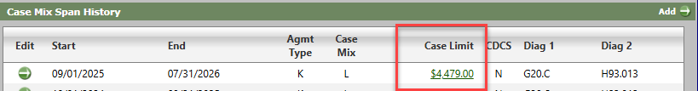
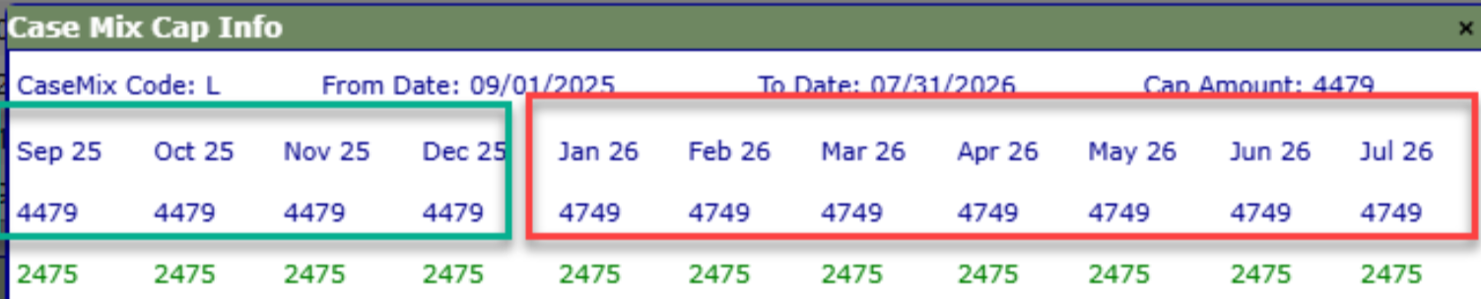

- Care Coordinators, who have members with an approved Request to Exceed Case Mix Cap, must review Bridgeview to determine if services will now fit under the 2026 case mix cap.
  - If services will fit, notify Blue Plus by emailing Partner.Relations@bluecrossmn.com and request that Bridgeview be updated.
    - Partner Relations will then work with the Bridgeview team to correct the member’s LTCC/Case Mix.

