changes to diabetic supplies for msho enrollees starting january 1st

Beginning January 1, 2026, coverage for test strips and meters will be limited exclusively to Ascensia products.
- To support this transition, members will be eligible to receive a complimentary Ascensia monitor. If a member requests help obtaining one, please follow the instructions outlined in the attached sample member letter.
- Starting January 1, 2026, both new and existing members may receive a one-time courtesy fill of their current test strip brand. This is intended to provide additional time to switch to Ascensia or to submit an organization determination request if necessary.
- The organization determination process will remain available to evaluate clinically appropriate reasons for not using Ascensia products—for example, if a member’s insulin pump is only compatible with another brand.
- Prime Therapeutic staff are doing member outreach re: this change.
- If you’d like a list of impacted members, please contact your Partner Relations Consultant.

Letter mailed to impacted enrollees in November:
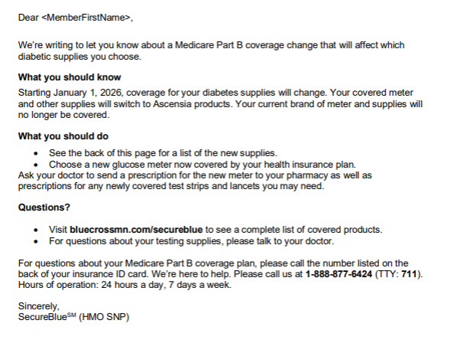

2026 Glucose Monitors And Test Strips:
