CDCS Legislative rate increase effective 1-1-2026
CARE COORDINATOR ACTION REQUIRED BY 12/31/2025

CDCS Budget Adjustments
- Elderly Waiver (EW) Budget Increase: CDCS EW budgets will increase by 6.013%.
  - Lead agencies must notify all members receiving CDCS services of their updated CDCS maximum budget.
  - Refer to Care Coordinator Action Items, Member Action Items, and Care Coordination Action Items Upon Receiving Signed Addendum below for details.
- Enhanced CDCS Rates: Increase from 7.5% to 12.5%.
- Holiday Pay: Christmas Day (December 25, 2025) is now a paid holiday.
- Caregiver PTO: Up to 120 hours of accrued PTO must be paid upon termination of employment (managed by the FMS).
- Service Rate Adjustments:
  - If a member receives a formal MA Home Care service such as SNV, home health aide services, PCA, and CFSS, rates will be adjusted in the back end, but will display in Bridgeview at the previous rate until next RA.
  - Even with separate line authorizations, these amounts are deducted from the CDCS budget. Care Coordinators should evaluate if these rate increases will potentially move a member over budget and if their service plan may need to be revised by the member, FMS, and support planner. Follow normal DTR process if applicable.
- EW Services:
  - EW services impacted by the COLA increase and approved under CDCS (T2028), such as home delivered meals, must be communicated to the member, and service plan must be revised by the member, FMS, and support planner if applicable. Care Coordinators should evaluate if these rate increases will potentially move a member over budget. Follow normal DTR process if applicable.
    - If using a DHS-contracted provider, we must pay the 1/1/2026 COLA rate.
- Paid Medical Leave Program:
  - Effective January 1, 2026, all MN employees are covered under the new Paid Medical Leave program.
  - Impact:
    - 0.44% tax increase on the plan.
    - 0.44% payroll deduction from employee wages (including bonuses).
  - This change must be communicated to the members, and plan must be revised by the member, FMS, and support planner if applicable.

Care Coordinator and Member Action Items
To be completed by 12/31/2025:
- Complete the following fields within the Participant Information section of the DHS-6633A:
  - See below for required fields and an example of how to calculate this section.
- Send document to all CDCS members, FMS providers, and if applicable, Support Planners.
  - Ensure members understand they must sign, date, and return the Addendum or substitute document.
- Case note the completion/sharing of this information.

Member Action Items
- To allocate COLA funds, members/legal representatives must complete and return a signed Addendum (or substitute document).
  - If the Care Coordinator does not receive the signed/dated addendum (or substitute document), COLA funds remain unallocated.

Care Coordinator Action Items Upon Receiving Signed Addendum
- Review the completed Addendum (or substitute document) received from the member and decide to approve, pend, or deny changes.
- Communicate decision to the member/legal representative, FMS, and Support Planner, if applicable.
- Document decision and notification of decision in case notes.
- Update T2028 authorization in Bridgeview (see section CDCS Legislative Rate Changes for guidance).

Example of How to Calculate Amounts in the DHS-6633A
- In this example, the CDCS span is from: March 1, 2025 – February 28, 2026 (12 months total).
  - If you need assistance calculating a span, please reach out to Partner.Relations@bluecrossmn.com.
- Case Mix E rates:
  - 2025: $8,837 per month
  - 2026: $9,369 per month
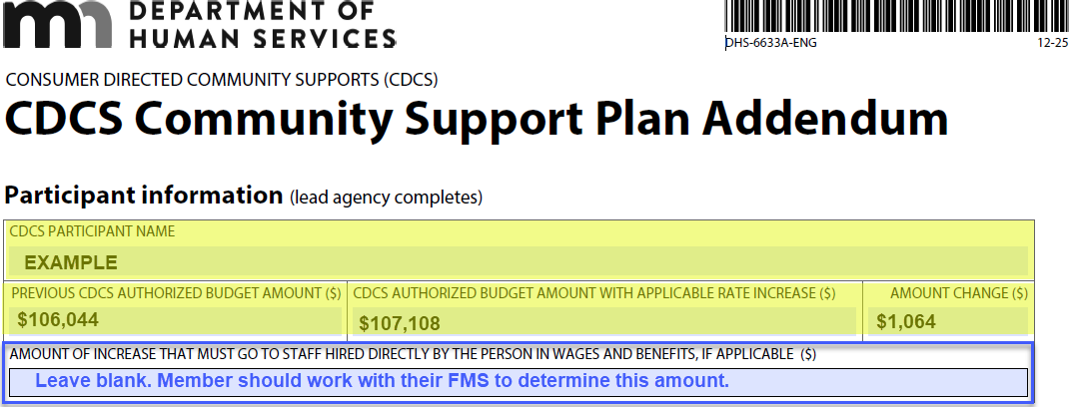
1. PREVIOUS CDCS AUTHORIZED BUDGET AMOUNT ($) (Pre-COLA)
- This is simply the entire span calculated at the 2025 rate, ignoring any increases.
- 12 months × $8,837 = $106,044
- CDCS AUTHORIZED BUDGET AMOUNT WITH APPLICABLE RATE INCREASE($)
- Here, you split the span into two parts (2025 months vs. 2026 months) and apply the correct rate for each:
- 2025 portion: March–December = 10 months × $8,837 = $88,370
- 2026 portion: January–February = 2 months × $9,369 = $18,738
- Total including rate increase: $88,370 + $18,738 = $107,108
- AMOUNT CHANGE ($)
  - The difference between the adjusted budget and the pre-COLA budget: $107,108 − $106,044 = $1,064

