msho supplemental benefit updates

2026 Care Coordinator resources for MSHO Supplemental Benefits are being updated and posted.
Check the SecureBlue MSHO Supplemental Benefits website for the most up-to-date information.
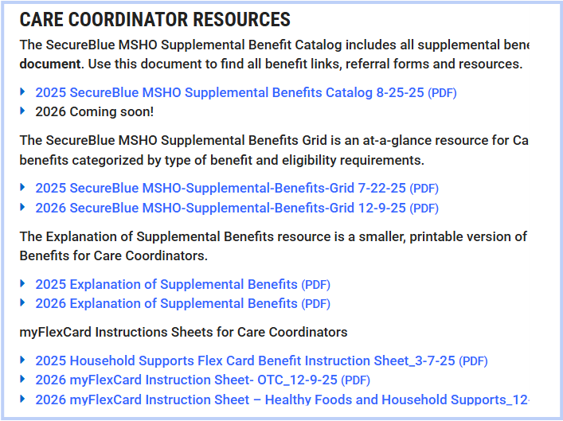

2026 Supplemental Benefit referral forms are available below.
If you plan to submit a referral in December for a 2026 benefit, make sure to indicate to the provider that services are for after 1/1/26. Ensure the member will be eligible for MSHO and meet the 2026 benefit eligibility criteria. Reminder: eligibility for some MSHO supplemental benefits will be changing 1/1/26. See the 2026 SecureBlue MSHO Supplemental Benefits Grid for details.
$750 In Home Safety Benefit Referral Form
Alliance Music Therapy Referral Form (PW: musictherapy26)
Ceresti Intake Form
Dose Referral
Juniper Referral
LSS Referral Form
QMedic Referral Form
SilverSneakers

myFlexCard
Members who have a myFlexCard in 2025 should keep their card in 2026. Members who don’t have a card in 2025 will receive a myFlexCard in January 2026.

Save-the-Date: 2026 SecureBlue MSHO Annual Supplemental Benefits webinar training
This training will include presentations from our SecureBlue MSHO Supplemental Benefits providers.
Date: January 7, 2026
Time: 10AM – 11:30AM
Click here for TEAMS invite

Contact your Partner Relations Consultant with any questions.

