CFSS & Bridgeview Reminders
- Once a member has transitioned from PCA to CFSS, they cannot go back onto PCA.
  - At reassessment, if you do not have an approved service delivery plan, please refer to the CFSS Guidelines found on Blue Plus’s Care Coordination website. Follow the process outlined under heading Temporary Approval.
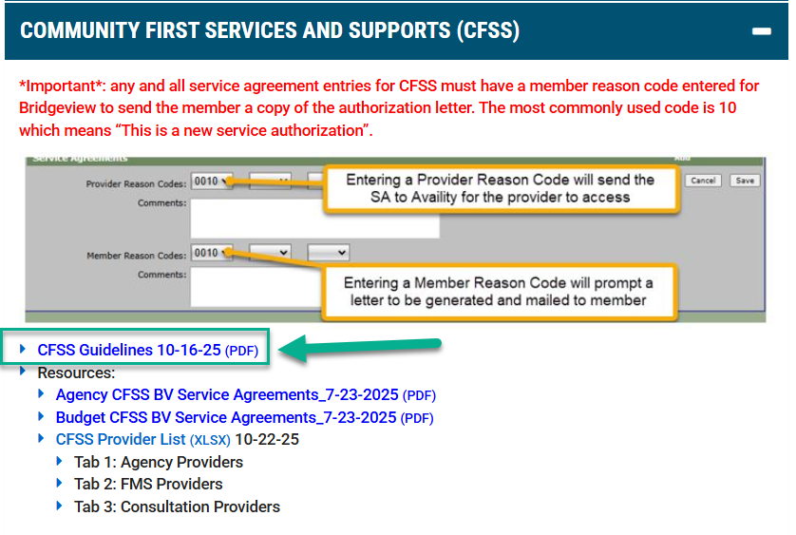
  - If, after reviewing, you have additional questions, please contact your PR Consultant.
- Reminder that CFSS authorizations are not found in Helios. If providers reach out to you, asking about an auth:
  - Direct the provider (s) to access the authorizations in Availity-Payor Spaces, where they can view and print authorizations.
  - Advise that when providers are submitting claims for CFSS, they must choose Bridgeview as the payor, not Blue Plus Medicaid.
  - Direct providers to contact Bridgeview directly for any questions at 1.800.584.9488 or email EWProviders@bluecrossmn.com.
- Bridgeview service agreements should only be amended in the following instances:
  - If a member transitions from PCA to CFSS and has an active PCA authorization. 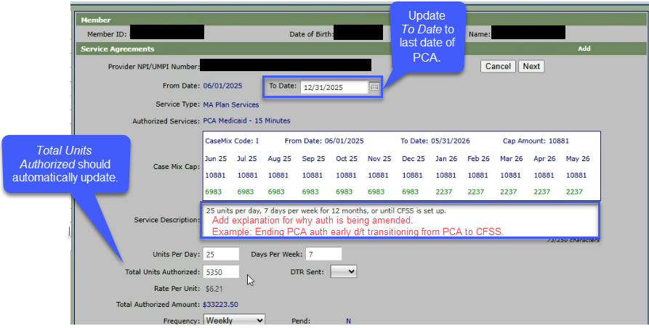
    - No DTR required.
    - After amending the PCA authorization, enter the CFSS service agreement. Refer to Service Agreement resources on the Care Coordinator website.
      - *The approved service delivery plan should include the number of CFSS units to be authorized.
      - From Date is date of signed plan, To Date is the end date of current span.
  - When completing an early reassessment.
    - Update To Date to 1 day prior to your new span’s start date.
    - Total Units Authorized should automatically update.
    - Add an explanation for why the auth is being amended in the Service Description field. Example: Amending due to early reassessment. This tells the Bridgeview team why you made this change.
    - A DTR is not required if services are not being denied, terminated, or reduced.
  - Increasing units.
    - Refer to the Bridgeview User Guide, specifically heading How to Increase Total Authorized Units for two options to accomplish this.
    - For either option, be sure to add an explanation for why auth is being amended in the Service Description field. Example: Increasing SNV units due to recent hospitalization. This tells the Bridgeview team why you made this change.
  - If you made a mistake entering an authorization and discover the mistake before claims have been paid.
    - Refer to the Bridgeview User Guide, specifically heading Closing Service Agreement entered in error or no longer needed; Claims Have Not Been Paid.
    - Be sure to add an explanation for why the auth is being amended in the Service Description field. Example: Errors in SA so ending to correct. This tells the Bridgeview team why you made this change.
    - *If you discover a mistake after claims have been paid, or if you are unsure if claims have been paid, please email Bridgeview.Service.Agreements@bluecrossmn.com before making updates.
  - For all other scenarios, where you believe you should amend an authorization, please send an encrypted email to Bridgeview.Service.Agreements@bluecrossmn.com.
    - A member of the Bridgeview team will advise you on how best to manage your unique situation.

