LIS Rider Letter mailing –

changes to prescription drug coverage for 2026
Low Income Subsidy (LIS) Rider letters and Loss of Deemed Status letters were mailed on Friday 9/19/25 to SecureBlue MSHO members. These letters provide a description and the costs associated with their prescription drug coverage for 2026. Members may notice a change to their prescription copay and may contact Member Services at 1-888-740-6013 with questions.
LIS Rider letter – this letter will indicate changes to the member’s prescription copays based on low-income subsidy status:
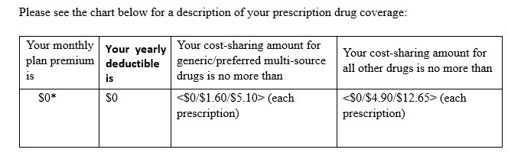
Loss of Deemed Status letter – this letter will indicate if the member doesn’t qualify for Medicaid or “Extra Help” and next steps to take:
