Bridgeview Web Tool Updates

The following Bridgeview web tool enhancements were deployed yesterday:

New Daily Cap on Case Management & Case Aide services
- Case Management T1016 UC and T1016 TF UC Case Aide: each code has a limit of 30 units per day per member.
- If a claim is submitted for >30 units per day, the claim will be rejected for being over the daily limit.

T2029 Nutritional Supplements increased from $4.25 to $4.50 per can

Navigation links added to HRA Audit Dashboard
- Added navigation links to the HRA Audit section. These links include Home, Date, Region, and Delegate.
- Clicking on any of these links should direct the user to the corresponding sections.

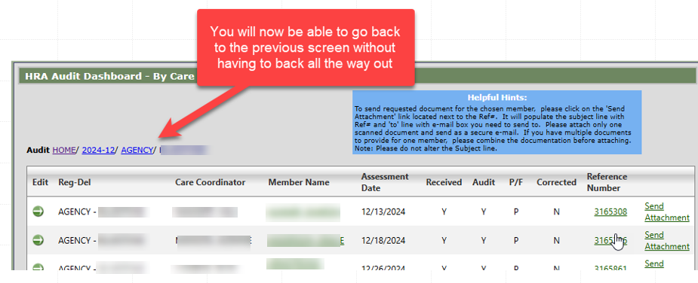

CDCS Limit has been removed from the LTCC & Case Mix History in Bridgeview
- Because CDCS budget limits are now the same as EW budget limits, we have removed the CDCS Limit field.
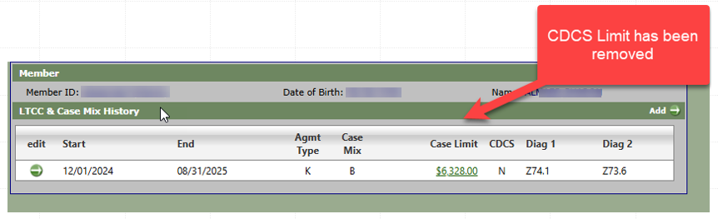

Group/living arrangement changes were erroneously creating an ‘Assessment Due’ flag for Care Coordinators – this has been fixed.

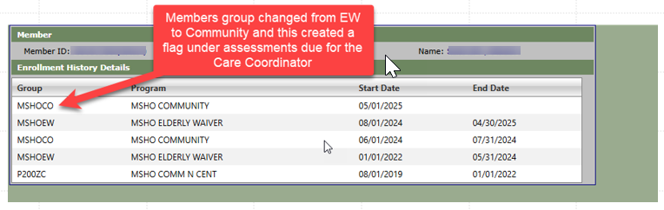

Updates to Delegate and Care Coordinator dates when a member is reinstated
We have been made aware that when a member is termed but then reinstated with active coverage, the ‘To Date’ for both Delegate and Care Coordinator assignment was not updated. This has been fixed.

