CMS Reaudit REsults & BLUE PLUS COORDINATOR GUIDANCE

CMS Corrective Action Plan (AAP) RE-AUDIT FINDINGS
The CMS re-audit for Blue Plus’s corrective action plan has concluded. Files were found to be non-compliant.
- Please thoroughly review the instructions, as they include updated clarification about required language.
- If, after review, you require further clarification, please reach out to your manager or your PR Consultant for additional guidance.

key issue
Bue Plus and CMS identified that member diagnoses and health conditions found in assessments are not consistently being addressed in Support Plans.
- The CMS requirement states:
  - The individualized Support Plan/ICP must address active health conditions and diagnoses identified in the health risk assessment (HRA). If the member chooses not to include a goal for an active health condition or diagnosis in their Support Plan, this preference and the support they receive should be documented in the Support Plan. This can be listed in any comment field in the Support Plan.
- Defining diagnoses and health conditions in the context of MnCHOICES assessments:
  - Diagnoses: ICD codes/diagnoses from a member’s MnCHOICES profile that are pulled into the MnCHOICES assessment.
  - Health conditions: Any disease, illness, injury, and assessed need (dentures, glasses, transportation, etc) referenced anywhere within the MnCHOICES assessment – including narrative sections – impacting their physical or mental well-being.
  - Reminder that current DHS Protocols require an enrollee’s assessed needs and concerns—related to primary care, acute care, long-term services and supports, mental health, behavioral health, and other service needs—be addressed in the Support Plan.
- The above CMS requirement applies to all assessments and Support Plans completed or reviewed on or after February 1, 2025, including:
  - Initials and reassessments, product changes (BP MSC+ to BP MSHO), health plan changes (another MCO to Blue Plus), transitions from Fee-for-service to Managed Care, and HRA and Support Plans created by Care Coordinators for members with another waiver Case Manager (CADI, etc).
- MnCHOICES does not flag when a Support Plan is missing diagnoses, health conditions, or assessed needs. Manual checks are required.
- Please refer to Blue Plus’s Communiques, sent 1/24/2025 & 6/13/2025 for additional details.

important UPDATE to documentating member choice for not creating goals to address diagnoses and health conditions
Following the CMS re-audit, Blue Plus learned that CMS expects the Support Plan to explicitly state the member’s choice to not pursue goal(s) for diagnoses, health conditions, and assessed needs.
- This expectation reinforces person-centered planning by requiring the Care Coordinator to clearly document evidence of a discussion about diagnoses, health conditions, or assessed needs, and note members’ choices around them.
  - When a Support Plan does not include goals tied to identified diagnoses, health conditions, or assessed needs, it must be clearly documented that this omission is because of member choice and not an oversight by the Care Coordinator.
  - Example: Jane did not wish to create a goal for diabetes, high blood pressure, and anxiety, she plans to see her PCP regularly for support.
    - This language:
- Shows intentionality.
- Affirms member engagement in the planning process.
- Affirms members’ choices.

Required care coordinator action
- For assessments and Support Plans completed or reviewed on or after February 1, 2025 through July 31, 2025, Care Coordinators must complete a file review to ensure CMS compliance. Further instructions are provided below.
  - This review must include initials, reassessments, THRAs, and TFNUs.
  - The file review can be completed during mid-year outreach.
    - If a mid-year contact has already occurred, CCs must review for CMS compliance within 60 days of the date of this Communique.
- Moving forward, Care Coordinators must ensure that every assessment and Support Plan, including THRAs and TFNUs, fully complies with CMS guidelines at the time it is finalized.

HOW TO REVIEW A FILE FOR COMPLAINCE:
- Review assessments and note diagnoses, health conditions, and assessed needs.
- Are all diagnoses, health conditions, and assessed needs found in the assessment - including narrative sections – addressed as required in the Support Plan?
- Ensure Care Coordinator comments, found within the assessment documenting members’ choices, are reflected within the Support Plan.
- If a member declines to create a goal for diagnoses, health conditions, and assessed needs, the Support Plan must:
  - document this preference in any comment field (e.g., Staying Healthy, Current Health Conditions, Services and Supports etc.), and describe any formal or informal services/supports the member receives to manage the condition or diagnosis.
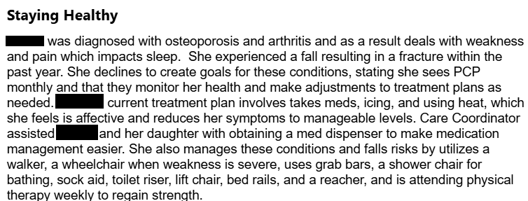
- If goals do not address diagnoses, health conditions, and/or assessed needs but a formal or informal service/support is established, is there a clear link made between the service/support and the applicable diagnosis, health condition, and/or assessed need?
  - Per CMS, having a formal or informal service/support in place does not satisfy the requirement to carry over all health conditions / diagnoses or needs from the assessment into the Support Plan unless there is an explicit connection made between the service and a diagnosis, health condition, and/or assessed need.
  - One service can address multiple diagnoses, health conditions, and/or assessed needs.

WHAT TO DO IF THE SUPPORT PLAN IS NOT COMPLIANT WITH CMS REQUIREMENT?
- If the Support Plan is not compliant, revise it in MnCHOICES, as it is an active, working document.
  - If you are unsure whether the Support Plan meets compliance requirements, consult your supervisor or contact your Partner Relations Consultant.
- A new signature page may not be required if revisions are strictly administrative; however, DHS recommends obtaining a new signature if the changes could impact the person’s understanding or agreement with the plan.
- A signature is required if revisions affect services, providers, goals, or preferences.

COMPLIANT support plan examples
- Writing goals inclusive of diagnoses, health conditions, and/or assessed needs and documentation that support is not requested. Goals can address multiple issues.
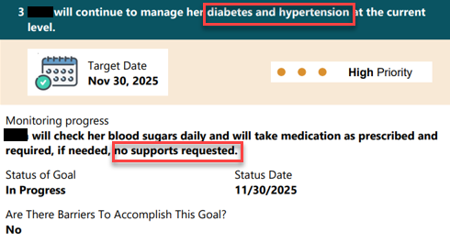
- Writing goals inclusive of diagnoses, health conditions, and/or assessed needs and documentation that support is requested. Goals can address multiple issues.
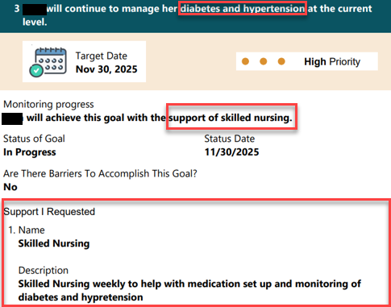
- Documenting member choose to not have a goal for diagnoses, health conditions, and/or assessed needs, and noting how they are managing in the Support Plan. Support Instructions within Services and Supports can be used to document a clear connection to the service and the diagnosis, health condition, and/or assessed need, and should note the member’s choice around not creating a goal.
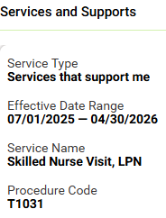
- Support Instructions within Services and Supports can be used to document a clear connection to multiple diagnoses, health conditions, and/or assessed needs, and should note the member’s choice around not creating a goal.
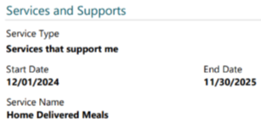
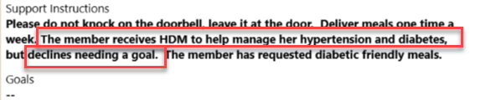
- Support Description within People and Community Organizations That Support Me can be used to document a connection between a person or organization providing support and a diagnosis, health condition, and/or assessed need, and should note the member’s choice not to create a goal.
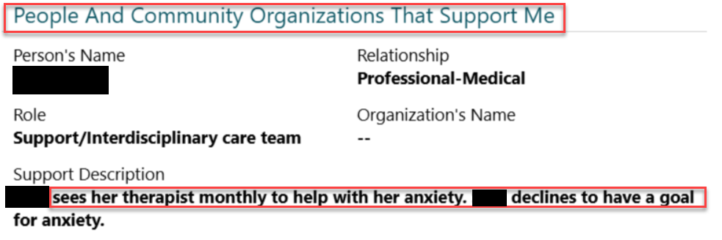

ADDITIONAL GUIDANCE FOR thras & MNCHOICES “Transfer” FUNTIONAL NEEDS UPDATE (TFNU)
WHEN USING BLUE PLUS’S TRANSITIONAL HEALTH RISK ASSESSMENT (THRA) OR A MNCHOICES “TRANSFER” FUNCTIONAL NEEDS UPDATE (TFNU) CARE COORDINATORS MUST:
- Fully review the assessment and Support Plan being paired with the THRA or TFNU, as described above.
  - Reminder: When assessments and Support Plans were completed by others, the newly assigned Care Coordinator inherits all associated audit risks.
- If a diagnosis, health condition, and/or assessed need is not addressed in the Support Plan, a revision must be completed.
- Obtain a new signature page if required.
*Care Coordinators may refer to the new resources “Support Planning Requirement Templates.” The above process will be revisited during Fall Training, though earlier training sessions may be accommodated upon request.*

