Bridgeview CFSS and Transitional MA Plan PCA Reminders

For Care Coordinators:
For Transitional MA Plan PCA service agreements, if there is a need to extend the authorization dates due to CFSS care plan not ready to implement, do not change the existing authorization. Create a new one for the additional time.

For CFSS Providers:
Care Coordinators frequently contact Bridgeview asking where to find the authorization for CFSS. Authorizations for CFSS are located in Availity-Payer Spaces, not Helios. If contacted, Care Coordinators can:
- inform the Provider(s) to access the authorizations in Availity-Payer Spaces. They can view and print those authorizations.
- advise when providers are submitting their claims for CFSS they must choose Bridgeview as the payor, not Blue Plus Medicaid.
- direct providers to contact Bridgeview directly for any questions at 1-800-584-9488 or email: EWProviders@bluecrossmn.com

Transfer FNU (TFNU) and Transitional HRA (THRA) Reminder to enter correct HRA Form Used

When entering a THRA or TFNU you must select 6.28 TRANS HRA or TRANSFER FNU in the HRA Form Used field.

We’re finding what appears to be transitional HRAs related to product or plan changes entered into Bridgeview as either R-MNCHOICES ASSESSMENT or HRA-MCO assessment. In many cases, TFNUs and THRAs are not full assessments and, importantly, do not include a new care plan. Because of this, they should not be entered as full assessments in BV. When listed as such, they bypass the date of the previous FFS or full assessment and care plan, which affects the proper 365-day reassessment tracking. If entered correctly, the next reassessment due date will be flagged correctly using the date of the assessment NOT the date of the THRA or TFNU.

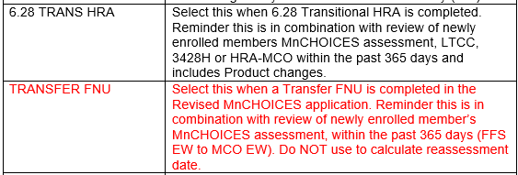
Complete instructions for proper entry of both Transfer FNU and Transitional HRA can be found in the Bridgeview Care Coordination User Guide

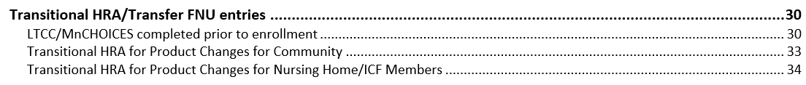
Significant Health Change assessments

Care Coordinators should not select SIGNIFICANT HEALTH CHANGE under “Type Of Assessment” in Bridgeview unless you completed a full assessment and your intent is to reset the waiver span. This will reset your 365-day reminder for reassessment.

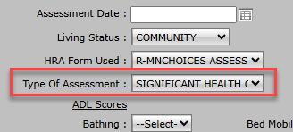
If a significant health change has occurred and the Care Coordinator’s intent is only to modify case mix and services (previously referred to as Activity Type 10), the following applies and will not impact your 365-day reassessment schedule:

- Adjust only the LTCC span in BV: set a new start date but retain the original end date from the previous full FF assessment. Mark Y under Activity Type 10 FNU.

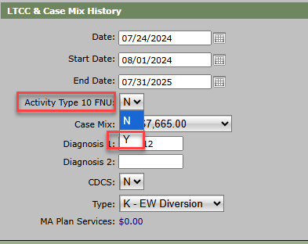

- Create necessary changes in Service Authorizations

- Do not enter another Health Risk Assessment entry into Bridgeview as we want the next reassessment due date to correctly calculate from the date of the assessment not the date of a significant change assessment (formerly Activity Type 10)

