Important MnCHOICES reminder: All Care Coordinators must be Certified Assessors.

The partner relations team has recently received a report from DHS with a list of Care Coordinators whose MnCHOICES certification has lapsed. As we reached out to those Delegates, we felt that a few important reminders about certification is warranted.

- Each delegate agency must have a process in place to monitor and track Certified Assessor Status. Certified Assessors must renew prior to expiration.

- As communicated by Blue Plus in multiple ways and required by DHS contract all MSHO and MSC+ Care Coordinators (except physician’s assistants, nurse practitioners, and physicians acting as Care Coordinators for members in nursing homes) must be Certified Assessors providing both the assessment and ongoing case management functions for enrollees, including Support Planning (excerpt from our CC guidelines):
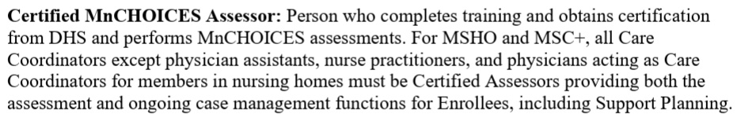
- Many of those on the DHS list were CCs that left the agency or moved into a leadership role and no longer needed certified assessor permissions (role). Our security team must submit the request to terminate or update (remove Care Coordinator and/or Certified Assessor) their MnCHOICES access. For this to occur Delegates must notify us by completing our Access Request form indicating that they need to be removed or updated in MnCHOICES. The form can be found on either the Bridgeview or MnCHOICES pages of our CC website.

- A new requirement from DHS will increase the need for diligence as they have communicated that they will be updating the roles and permissions in MnCHOICES. All Care Coordinators will be assigned only one role, which will be a Care Coordinator. The role of Care Coordinator will indicate that they are both the Care Coordinator and a Certified Assessor. It is imperative that Delegates ensure that all Care Coordinators are and remain active Certified Assessors.
- For Care Coordinators that have a lapse in their certified assessors status immediately follow the guidance found here under “Getting recertified after a lapse”: https://www.dhs.state.mn.us/main/idcplg?IdcService=GET_DYNAMIC_CONVERSION&dID=96821

- Additionally, Delegates must review and notify us of MnCHOICES Mentor changes on an ongoing basis. Mentor List is located on website (last uploaded in July 2024): https://carecoordination.bluecrossmn.com/mnchoices/mnchoices-mentors/

