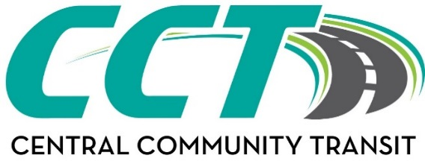
Website: www.cctbus.org

Litchfield Office  812 East Ripley ~ P.O. Box 36  Litchfield, MN 55355  Phone: 320-693-7794 | Willmar Office  1320 22nd Street SW ~ P.O. Box 186  Willmar, MN 56201  Phone: 320-214-7433 | Olivia Office  612 East Lincoln  Olivia, MN 56277  Phone: 320-523-3589
BRIDGEVIEW SERVICE VOUCHER
Agency/Individual: This form must be completed & accompany all requests for transit goods (passes/tokens) from CCT.

Completed form must be sent to: accounting@cctbus.org or faxed to: 320-214-7754

Visit the website above or contact the applicable office by phone to discuss the value of each option below to determine which Punch Pass or Tokens options would work for the request. Do not send this form to individual offices.

AUTHORIZATION FOR PURCHASE OF:
# | Punch passes @ $22.50* | $
# | Punch passes @ $42.50* | $
# | Punch passes @ $60.00* | $
# | Punch passes ($5 increments) @ $125.00* | $
# | Tokens @ $2.50* ea. | $
Required: Add S&H fee (fee subject to change)* *(limit of up to 4 passes in one mailing; |  | $ 6.00
 | TOTAL | $
*Prices includes an additional Admin fee
SPECIAL INSTRUCTIONS:
PAYMENT FORM:
Bill to: EMAIL: EWBusPasses@bluecrossmn.com

MAIL TO: | <Recipient Name>
<Recipient Address>
<Recipient Address>
 | <Recipient Telephone #>

Recipient has been notified of the above

AUTHORIZED BY: | <Electronic Signature>
 | <Enter Care Coordinator Name>
 | <Delegate Agency Name>
 | <Agency Address>
 | <Care Coordinator Phone #>

Office Use Only: | Date Mailed:
 | By Staff:

