Updates to CFSS Approval Process
Per the DHS AASD and DSD eList announcement on 1/7/2025, DHS updated the CFSS Policy Manual to add instructions for lead agency use of DHS-6893W Lead Agency Addendum to CFSS Individual Service Delivery Plan.

Specific guidance can be found in the CFSS Policy Manual – CFSS service delivery plan development and approval process which includes a helpful overview of steps to be taken for someone wanting to utilize CFSS after an assessment determines their eligibility.

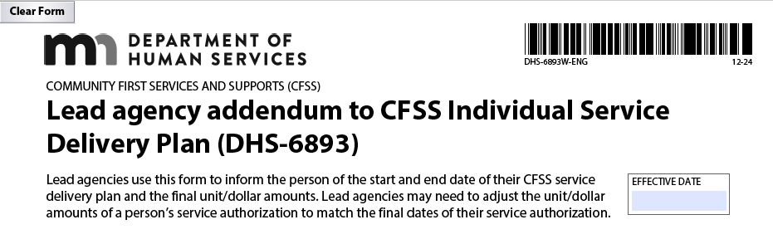
Updated guidance for Care Coordinators includes:
- After consulting with the member, the Consultation Services Provider finalizes the DHS 6893P - CFSS Individual Service Delivery Plan. The consultation provider will review and offer the member guidance to ensure the plan is complete, meets the person's assessed needs, and contains only covered CFSS goods and services.
- The Consultation Services Provider sends the plan to the Care Coordinator.
- The care coordinator must review the plan. If the Care Coordinator agrees with and approves the plan, the Care Coordinator must complete the "Lead Agency Addendum to CFSS Individual Service Delivery Plan DHS-6893W" (found only in eDocs) and adjust the start date on the CFSS service delivery plan based on the member's situation:
- A person currently using PCA: the start date immediately following the end of their 3-6 month PCA transition authorization.
- A person new to CFSS: The start date is when the care coordinator approves the CFSS service delivery plan.
- Care Coordinators will also need to review and add the member's CFSS authorizations in Bridgeview to reflect the final approved plan and budget.

Blue Plus is working on the creation of a checklist for CFSS and will let Care Coordinators know when it is final and posted on the care coordination website as a resource.

In the meantime, please direct any questions about CFSS to your Partner Relations Consultant. Thank you!

