SECUREBLUE MSHO SUPPLEMENTAL BENEFIT REMINDERS AND UPDATES
SecureBlue MSHO Supplemental Benefit reminders and updates
- 1/8/2025 MSHO Supplemental Benefit Training: Thank you for those who attended. The recorded training, slides, and Q&A are posted to the Care Coordination Training webpage. If you have questions not answered within the Q&A, contact your Partner Relations Consultant or email Partner.Relations@BlueCrossMN.com. The Q&A will be updated and reposted as additional questions are submitted, so continue to refer to our website with questions.
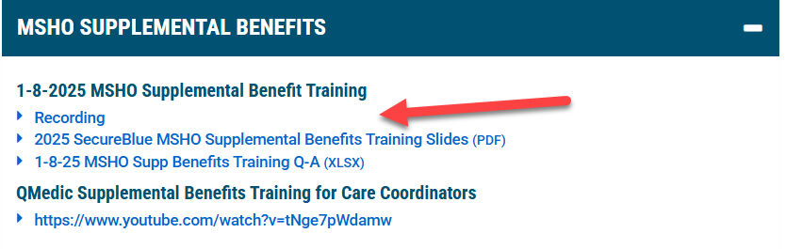
- Care Coordinator Resources: 2025 resources have been posted. Visit the SecureBlue MSHO supplemental benefits care coordination website for updated supplemental benefit resources, including updated referral forms.
- Household Supports and income determination for HUD: Effective Jan 2025, the U.S. Department of Housing and Urban Development (HUD) has released a Frequently Asked Questions (FAQs) clarifying when the use of supplemental benefits will be included in the determination of income pursuant to federal regulations for determining eligibility and rent-subsidies provided to the tenant. HUD requires that supplemental benefits received and used for rent and utilities must be included in the calculation of income performed by a housing provider or public housing agency. Any benefits other than used rent and utilities, or unused benefits (any portion of the Flex Card amount that is unspent) should not be counted in the income calculation.
For more information, see the FAQs linked here: https://www.huduser.gov/portal/publications/FAQ-Medicare-Advantage-Supplemental-Benefits.html.
- Household Supports Flex Card Mailing: The myFlexCard household supports debit cards were mailed to recipients between Jan 14th-15th. The new card must be activated prior to use. The CVS Visa household supports card can be destroyed after 12/31/24.
- Eligibility Reports for household supports and nutrition benefits: Care coordination delegates will receive an eligibility report at the end of January. We apologize for the delay. If you have questions about eligibility for your member prior to receiving the reports, you may contact Jenna.Rangel@bluecrossmn.com or your Partner Relations Consultant. Reminder: effective 1/1/25, members qualify for these services if they do not live in a nursing facility, and they have COPD, diabetes or hypertension.
- Household Supports verification of diagnosis/Signify: For MSHO members who say they have an eligible condition for a benefit but are not triggering as eligible per our claims data (may be because they use the VA for their care), members can opt to receive an annual in-home visit from Signify. All SecureBlue members can participate by calling Signify Health at 1-844-226-8218 (TTY 711), 7 a.m. to 7 p.m., Central Time, Monday – Friday and 8 a.m. to 4:30 p.m., Central Time Saturday or visit https://schedule.signifyhealth.com/home to schedule. Members may also find more information online at bluecrossmn.com/medicare-preventive.
As a thank you for completing the In-Home or Virtual Wellness Assessment, members will receive one $25 Mastercard gift card that is good for food purchases at grocery stores and restaurants where Mastercard and Visa are accepted. The gift card will be mailed after the visit is complete and can take 4-6 weeks to be delivered.
- 2025 CVS OTC Catalog Mailing: MSHO members who live in the community were mailed a copy of the 2025 CVS OTC catalog on 1/14/25. The mailing came from Blue Cross. All members may request one printed copy of the catalog directly from CVS by calling 1-888-628-2770 (in addition to the copy sent by Blue Plus). Catalogs can also be found online here: https://www.bluecrossmn.com/sites/default/files/DAM/2024-09/2025-secureblue-otc-catalog.pdf
- Assisting members with CVS OTC orders: Care coordinators may assist members with ordering their CVS over-the-counter items as needed. Care coordinators should not create online member accounts or log into the member’s CVS online account. If the member or caregiver cannot place the order on the phone, online, app or shop in store themselves and requests assistance from the care coordinator, see options below.
- Care coordinators can assist the member by calling CVS on their behalf at 1-888-628-2770 (TTY: 711)
- Care coordinators may fill out the attached CVS order template and email to CVS. See the template for instructions.
Other reminders:
- Supplemental benefits are approved on an annual basis by CMS.
- If you are referring a member to a supplemental benefit, please ensure they have active MSHO coverage and meet the eligibility criteria for each benefit.
- If a member is receiving on-going services from a SecureBlue MSHO supplemental benefit provider (Alliance Music Therapy, Ceresti, Dose, Juniper, LSS, NourishedRx, QMedic) and the member loses SecureBlue MSHO eligibility (i.e. due to redetermination, chooses another health plan, etc.), you must inform the provider that the member is no longer eligible, and services should be stopped. Supplemental benefit providers may not be aware that a member has termed from SecureBlue MSHO.
Please continue to share your comments on vendor or benefit experiences so we can improve the benefits for our members and processes for you. Send feedback to: jenna.rangel@bluecrossmn.com.

Thank you,
Partner Relations Team | Government Markets
Partner.Relations@bluecrossmn.com

