Effective January 1, 2025, DHS will implement the following rate and budget increases:

Legislative Rate & Case Mix Budget Increases Effective 1/1/2025
- 4.53% increase to AC and EW monthly case-mix budget caps.
- 4.53% increase to consumer-directed community supports (CDCS) budgets under AC and EW.
- 4.53% increase to EW 24-hour customized living daily and monthly limits. This change will happen on a rolling basis as lead agencies renew service plans throughout the year.
- 6.195% increase in home-delivered meals.
- State plan Home Care:
  - 3.14% increase in home health aide, skilled nursing, occupational therapy, physical therapy, respiratory therapy, and speech therapy (market basket adjustment).
  - 3.14% increase in home care nursing (market basket adjustment).
  - The same percentage increases also apply to extended home care services.
- PCA/CFSS rate increases include changes to the wage component value and implementation factor within the PCA rate framework:
  - 4.37% increase to 1:1 PCA/CFSS.
  - 4.37% increase in PCA supervision and CFSS worker training and development.
  - 4.37% increase in CSG PCA ratings.
  - The same percentage increases also apply to extended PCA/CFSS.

For more information, refer to the DHS 3945 Long Term Services and Supports Service Rate Limits and the DHS announcement on Long-term services and support rate changes.

Bridgeview auto-updates:
On Saturday, December 14th, Bridgeview staff automatically split and updated all service agreements that are subject to the rate changes for 1/1/2025, with the exception of 24-hour Customized Living, CDCS, and any T2029 items (since they are single-date service items).
- Care Coordinators should review service agreements for accuracy and update the care plan budget worksheet/MnC Support Plan to ensure the services are within the member’s EW monthly budget cap.
- If you notice any issues with your service agreement updates, please email Bridgeview.Service.Agreements@bluecrossmn.com.
- The new rate increases are not automatically applied to existing service agreements for EW CDCS budget increases and 24 CL rate plans. In the event the member requires additional services, the service agreements for EW 24-hour CL and CDCS will require the CC to review and manually split existing service agreements. Members must have unmet assessed needs with the current plan. If the member needs new or additional services, follow the guidance below. See more service specific details below.

EW 24-hour Customized Living (24-hour CL):
- 4.53% increase to EW 24-hour customized living daily and monthly limits.
- If a member needs new or additional service components, the Care Coordinator must complete a new RS tool, submit it to DHS, and do the following in Bridgeview:
- End the current CL service agreement on the last day of the month before the service rate limit change.
- Create a new CL service agreement starting January 1st that goes through the current span.

EW Case Mix Cap Increase:
- Care Coordinators may choose to add or increase services prior to reassessment, if doing so will better support member(s) remaining in the community based on assessed needs.
- The budget cap increase will display for any existing LTCC case mix spans from January 2025 to the end of the waiver span. To view, click on LTCC & Case Mix from menu option, and click on the Case Limit.
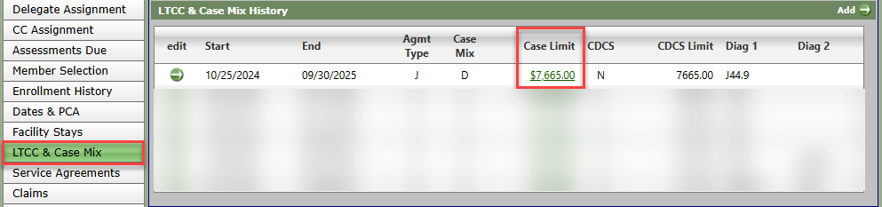
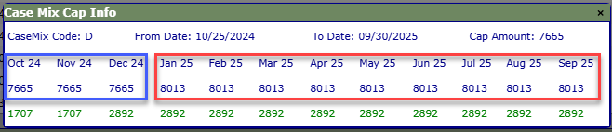

- Care Coordinators, who have members with an approved Request to Exceed Case Mix Cap, must review Bridgeview to determine if services will now fit under the 2025 case mix cap.
  - If services will fit, notify Blue Plus by emailing Partner.Relations@bluecrossmn.com and request that Bridgeview be updated.
    - Partner Relations will then work with the Bridgeview team to correct the member’s LTCC/Case Mix.

EW Consumer Directed Community Supports (CDCS) Service Rate Limits:
WHAT ARE THE CDCS CHANGES?

CDCS Budget increase
- All CDCS budgets will receive a 4.53% increase on 1/1/2025, matching the EW Case Mix Cap detailed in the Long-term Services and Support Services Rate Limits Effective January 1, 2025, DHS-3945

Mandatory Changes
- If staff (including Paid Spouse) is not at $20/hour, their wage must be increased to $20/hour.
  - The Care Coordinator must work with FMS (and Support Planner, if applicable) and update authorization in Bridgeview.
- If a member has approved home care services, Bridgeview has automatically updated impacted service agreements.
- If a member has approved home delivered meals from a licensed provider, rates must be communicated to the FMS (and Support Planner, if applicable).

NEXT STEPS:

- Complete the Participant information section on the 6633A.

- Care Coordinator must reference the below on how to determine the new CDCS budget. Please collaborate with your supervisor or contact Partner Relations if you need assistance.

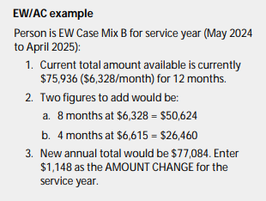
- Send addendum to the member before 1/1/2025 to inform them of the new up-to-CDCS budget.
- Send addendum to the FMS provider (and Support Planner if applicable).
- Case note the date the addendum was sent to the member, the FMS, (and Support Planner, if applicable).

WHAT TO DO IF MEMBER GOES OVER BUDGET AFTER RATE INCREASE:
Effective 1/1/2025, if any of these changes result in the member being over budget, the member must work with FMS (and Support Planner, if applicable) to move funds from other approved items/services to cover the overage. The Care Coordinator should reference the Bridgeview Care Coordinator User Guide (pg. 59-61) for instructions on updating the CDCS Services agreements with the increase.

WHAT TO DO IF THERE IS ROOM IN THE BUDGET AFTER RATE INCREASE:
Any unused funds will be considered “unallocated.” If member wishes to access unallocated funds, changes cannot be backdated, and an addendum must be completed. The following are examples:
- Increasing wages above the mandatory $20/hour.
  - Paid Spouse new maximum rates 1:1 with PTO is $23.74/hour and waiving PTO (will need to work with FMS) $24.84/hour.
- To increase staff hours or to purchase items.

If you have any questions, please contact your Partner Relations Consultant. Thank you.

