We realize we have updated our DTR Decision Guide scenarios several times recently and appreciate your patience. We are working with our Utilization Management (UM) and Compliance teams to ensure we are meeting contractual and regulatory requirements regarding DTR’s.
Denial, Termination, and Reductions (DTR) updates

We have again updated the Guidelines and the Care Coordinator DTR Decision Guide to provide further DTR clarification and direction.
- Provider Changes: Care Coordinators are not required to send a DTR when there is a change in service provider but no change in service, rates, or units.
  - Care Coordinator are required to notify the provider for which services are ending and case note the notification date. This is important to ensure that the former provider does not continue to provide/bill for services.
- Update Bridgeview Service Agreement end date for former provider to the date of notification.
- Create a Service Agreement for the new provider starting the day after notification, through the remainder of the current span.
- Services denied, reduced, or terminating at the end of a Waiver Span: Care Coordinators may proactively send in a DTR when it is known that services will be denied, reduced, or terminated at end of the waiver span.
  - The DTR form should be submitted at minimum 10 days prior to the waiver span end date to avoid the 10-day notice going into the new span.
  - Care Coordinators must note on the DTR comment section that the last date of current service(s) is the end date of current span and note this date.
Example: Reassessment was completed on 12/02/2024 for a new span start date of 1/1/2025. Member decided to end current services and start on CDCS 1/1/2025. Care Coordinator sends in a DTR at least 10 days prior to 12/31/2024 (end date of current span), indicating that the last date of services will be 12/31/2024.

The updated DTR decision guide, which includes all recent changes, can be found on the Care Coordination page of the CC website:
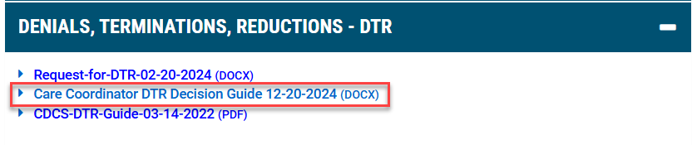

If you have any questions, please contact your Partner Relations Consultant.
Thank you.

