Denial, Termination, and Reductions (DTR) updates
We have again updated the Guidelines and the Care Coordinator DTR Decision Guide to provide further DTR clarification and direction with the following updates:

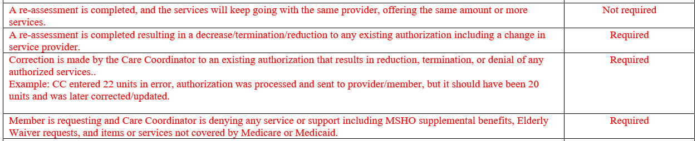

As a reminder, the Care Coordinator DTR Decision Guide can be found on the Care Coordination page on our website:

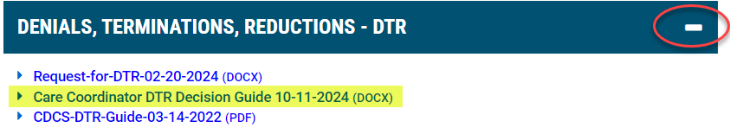
If you have any questions, please contact your Partner Relations Consultant.
Thank you.

