Per DHS policy, all CFSS providers must be contracted with DHS to provide services to members. Service agreements for CFSS cannot be entered in Bridgeview unless the provider is listed on our CFSS Provider List found on the Care coordination page of our website:

CFSS Provider Update
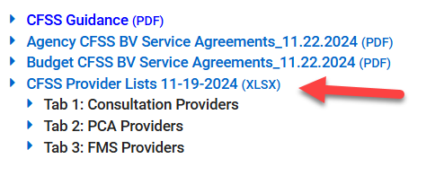
If a CFSS provider has not yet received their approval from DHS, please ask them the following questions:
- Has the agency completed/submitted all required documentation to become an DHS-contracted CFSS provider?
- Has the agency received any communication from DHS about their approval status?

If a provider has completed all required tasks and is waiting for their approval, please email your Partner Relations Consultant the following information:
- name and address of the provider
- provider type (Consultation, Agency, FMS), and
- where they are within the approval process.

Your PR Consultant can then email DHS to request the provider’s enrollment be expedited.

Please continue to refer to our Care Coordination website for additional CFSS information.

