The Care Coordinator User Guide has been updated and is posted to the Care Coordination and Bridgeview websites. The most recent changes will be in red font for easy identification. The following are a few highlights:
Bridgeview Care Coordination User Guide Updates
- New Screenshots added throughout
- Date of Death—Although Service Agreements are ended automatically when the date of death is entered, the units do not automatically modify and must be updated accordingly.
- Out of Network—new section added with instructions that the Service Description must include a note if the provider is out of network. And a note that CC confirmed the provider is enrolled with DHS (required).
- Claims—new section added with screenshot. Users can now view member’s medical claims (including MA State Plan and other medical procedures). No EW claims are included. This is a very high-level view of claims. Questions about specific claims need to be referred to Provider or Member services.
- Reports—Removed sections Renewal Reports; Enrollment Reports; and Types of Enrollment reports. This section is simply for how to access the reports in Bridgeview. All other actions and responsibilities related to each report can be found in the Care Coordination guidelines.
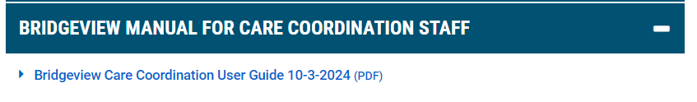
Let your Partner Relations Consultant know if you have any questions.

