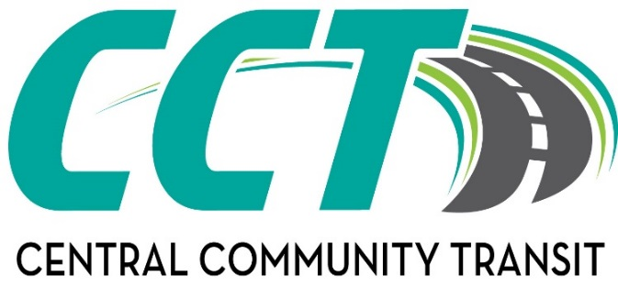

**Willmar Office Litchfield Office Olivia Office**

**320-214-7433 320-693-7794 320-523-3589**

[**willmardispatch@cctbus.org**](mailto:willmardispatch@cctbus.org)[**litchfielddispatch@cctbus.org**](mailto:litchfielddispatch@cctbus.org)[**oliviadispatch@cctbus.org**](mailto:oliviadispatch@cctbus.org)

**Bus Fare Rates**

**City Limits of Litchfield, Olivia, and Willmar $2.00 Each One-Way Ride**

**0-13 Miles $3.00 Each One-Way Ride**

**14-22 Miles $4.00 Each One-Way Ride**

**23-35 Miles $5.00 Each One-Way Ride**

**36 + Miles $6.00 Each One-Way Ride**

**Same Day Service Additional $1.00 Each way**

* Same Day Service, when available, requires an addition to the fare. Same day service also includes changing a prescheduled time or location.
* Bus Stop to Bus Stop Discount no longer available.
* One child age 4 and under rides free with one accompanied paying adult. Children age 3 and 4 going to a structured educational facility are able to ride and are expected to pay the regular fare.
* Veterans Ride Free when they provide their VA ID Card with an SC unless they are traveling to/from a structured service facility. (Same day charge of $1 does apply when making rides same day.)

**Discount Punch Passes Available:**

$20.00 Value Punch Pass Cost: $18.00 (10% Discount)

$40.00 Value Punch Pass Cost $34.00 (15% Discount)

$60.00 Value Punch Pass Cost $48.00 (20% Discount)

$110.00 Value Punch Pass ($5.00 punches only) Cost $100.00 (10% Discount)

Comments taken at www.cctbus.org