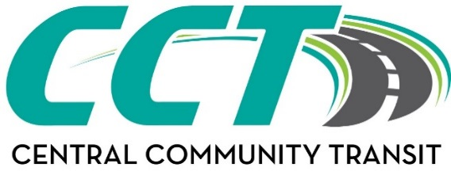
Website: www.cctbus.org

Litchfield Office  812 East Ripley ~ P.O. Box 36  Litchfield, MN 55355  E-mail: willmardispatch@cctbus.org  Phone: 320-693-7794  Fax: 320-593-2889 | Willmar Office  1320 22nd Street SW ~ P.O. Box 186  Willmar, MN 56201  E-mail: litchfielddispatch@cctbus.org  Phone: 320-214-7433  Fax: 320-214-7754 | Olivia Office  612 East Lincoln  Olivia, MN 56277  E-mail: oliviadispatch@cctbus.org  Phone: 320-523-3589  Fax: 3205231043
BRIDGEVIEW SERVICE VOUCHER
Agency/Individual: This form must be completed & accompany all requests for transit goods (passes/tokens) from CCT.
Visit the website above or contact the applicable office by e-mail or phone to discuss the value of each option below to determine which Punch Pass or Tokens options would work for the request.

AUTHORIZATION FOR PURCHASE OF:
# | Punch passes @ $22.50* | $
# | Punch passes @ $42.50* | $
# | Punch passes @ $60.00* | $
# | Punch passes ($5 increments) @ $125.00* | $
# | Tokens @ $2.50* ea. | $
Required: Add S&H fee (fee subject to change)* *(limit of up to 4 passes in one mailing; |  | $ 6.00
 | TOTAL | $
*Prices includes an additional Admin fee
SPECIAL INSTRUCTIONS:
PAYMENT FORM:
Bill to: EMAIL: EWBusPasses@bluecrossmn.com

MAIL TO: | <Recipient Name>
<Recipient Address>
<Recipient Address>
 | <Recipient Telephone #>

Recipient has been notified of the above

AUTHORIZED BY: | <Electronic Signature>
 | <Enter Care Coordinator Name>
 | <Delegate Agency Name>
 | <Agency Address>
 | <Care Coordinator Phone #>

Office Use Only: | Date Mailed:
 | By Staff:

