Community First Services and Supports (CFSS) program will launch on October 1, 2024.
Community First Services and Supports (CFSS)
This new program will replace the existing Personal Care Assistance (PCA) and Consumer Support Grant (CSG) programs. CFSS aims to provide more flexible options to meet individual's unique needs, allowing them to achieve greater independence in their homes and communities.

CFSS will cover services previously provided under PCA and CSG and add additional services, for example:
  - Consultation Services
  - Worker Training and Development
  - Goods/Services
  - Personal Emergency Response System (PERS)

The program offers more flexible options to better meet individual needs and helps people maintain greater independence in their homes and communities. CFSS offers two different models:
  - Agency Model: In this model, a CFSS agency manages the individual's personal care services. The agency is responsible for hiring, and training workers. The member can also have goods/services and PERS for which the Consultation provider will ensure is a part of the individual's service plan as desired.
  - Budget Model: This model provides individuals with a budget to manage their services and support. Members can hire workers, purchase goods/services, and manage there are according to their needs. This model offers greater control and customization of services.
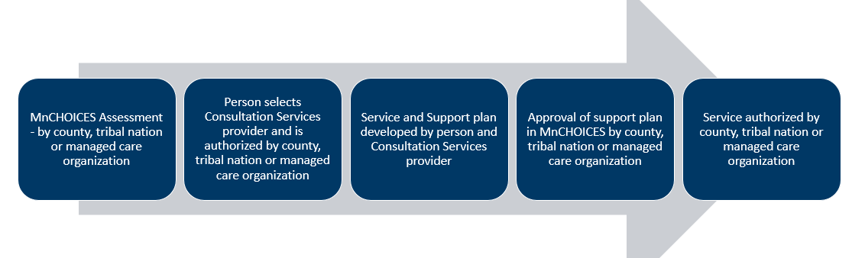
Transition Date: The transition from PCA and CSG to CFSS will begin with initials or reassessments completed on or after October 1, 2024.
  - Gradual Transition: To ensure that services continue without interruption, the transition from Personal Care Assistance (PCA) and the Consumer Support Grant (CSG) to CFSS will occur over a year.
  - Annual Reassessment: During their annual reassessment, individuals currently or qualifying and requesting PCA or CSG services will transition to CFSS.
- For Individuals New to CFSS:
  - Initial Steps:
    - Provide required documentation to the member:
      - Currently required assessment results within 10 days
      - Provide list of Consultation providers
      - Provide CFSS fact sheet DHS-8477A
    - After Consultation provider is selected by member create service authorization to include the full authorization for 6 sessions.
    - Approval Process: Once the plan is approved, CFSS services can be authorized.
- For Individuals Transitioning from PCA to CFSS:
  - Initial Steps:
    - Provide required documentation to member as stated above
    - Enter in Bridgeview a 3-month transition authorization. This entry is traditional PCA T1019 authorization based on assessment results and should include supervision T1019 UA.
    - After Consultation provider is selected by member create service authorization to include the full authorization for 6 sessions.
    - Approval Process: Once the plan is approved enter Service Authorization for CFSS prorated for 9 months. (Note: Consultation and Worker Training and Development are not prorated)
- Services Authorizations: will be entered into Bridgeview and if there are any concerns and questions reach out to the Bridgeview team at: bridgeview.service.agreements@bluecrossmn.com
All CFSS providers enrolled with DHS and Bridgeview can be utilized. If the provider is not enrolled with DHS, it cannot be used. If the provider is enrolled with DHS but not enrolled with Bridgeview, have the provider reach out to EWProviders@bluecrossmn.com or 800-584-9488.

We encourage you to visit the DHS CFSS website, where you will find detailed information about CFSS, including, CFSS Fact Sheet, transition details, FAQs, and training materials. Care Coordinators are highly encouraged to complete CFSS trainings.

Additional Resources:
CGSS Consultation providers
FMS providers

Please reach out with any questions.
CFSS Training Reminder

Care Coordination staff should prepare for October’s CFSS rollout by taking DHS’s CFSS training, if not yet completed.
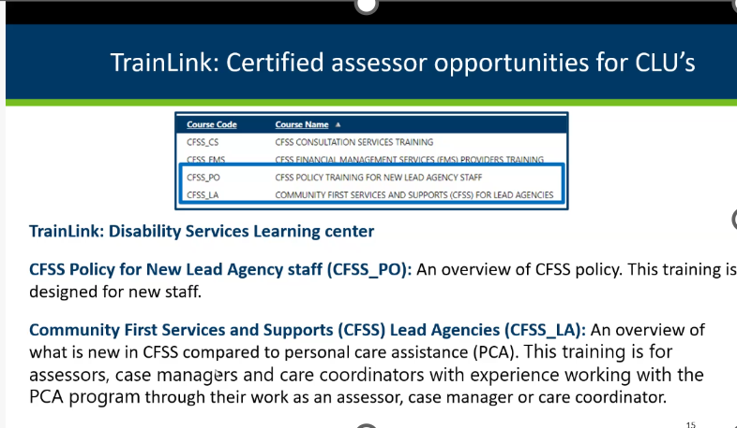

Helpful CFSS links to bookmark for future reference:
- Transition from PCA and CSG to CFSS
- CFSS Frequently Asked Questions
- CFSS Policy Manual
- DHS publishes CFSS Individual Service Delivery Plan Template

