Guidelines Updates
Thank you to those who have reached out asking questions about our recent Guidelines and checklist updates!
As a result of some of those questions, we have made the following updates to both documents.

Transitional HRA
When entering the THRA form details into MnCHOICES, Care Coordinators do not need to complete the Staying Healthy section at this time. This was an error on our part. The checklist and guidelines have been corrected.

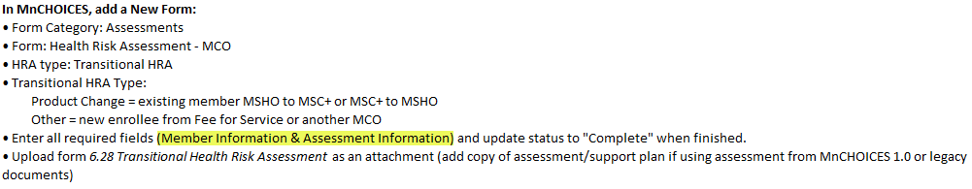
Goals: we removed the option of using only the goals section on form 6.28 Transitional HRA. All goals (including creation of new goals) should be done using the revised function on existing support plan in MnCHOICES.

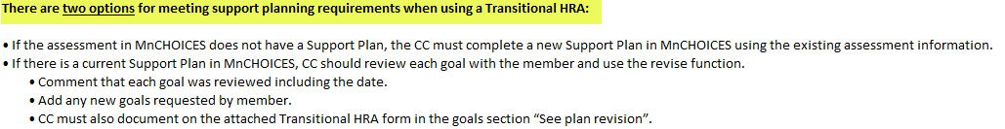

Service updates to the Support Plan
We have removed all references to utilization of 8.50 Member Change Letter when there are service changes – this includes state plan services and EW services.
Care Coordinators should follow DHS guidance and revise the support plan choosing “Yes” for signatures following this updated guidance:

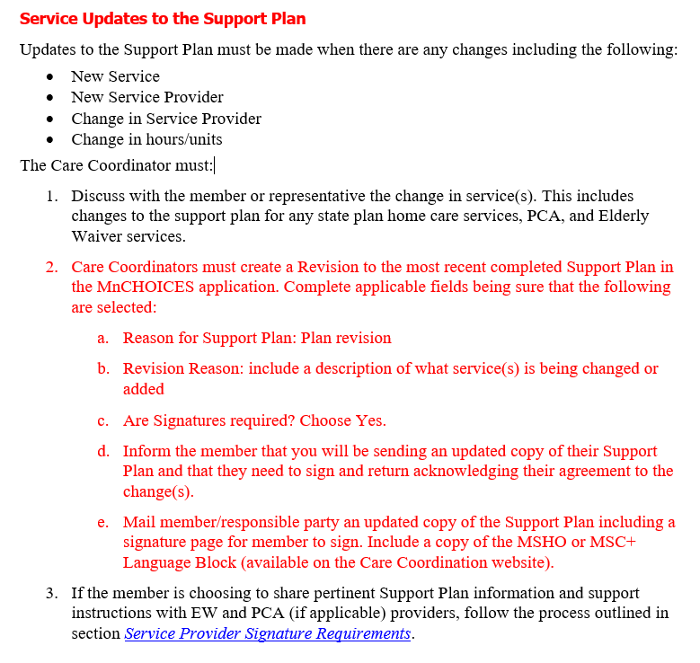
PCA Providers
We updated our guidance on what is required to be sent to PCA providers within 10 business days of the assessment.

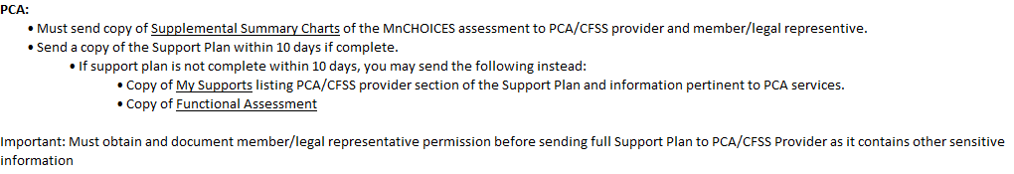
Caregiver Assessment
If an Informal Caregiver is identified in either the full MnCHOICES or HRA-MCO assessments, Care Coordinators must document their offering of the DHS 6914 Caregiver Questionnaire and attach to the member’s profile following this guidance:

Full MnCHOICES:
- Document offering (ie. CG assessment was offered and/or declined, mailed and/or completed etc.) under Functional Assessment - Community Living> Relationships Informal Supports comment box.

HRA-MCO:
- Document offering (ie. CG assessment was offered and/or declined, mailed and/or completed etc.) under Everyday Life>Taking Care of Self in the comment box.

Reminder: Add caregiver name under relationship type “Informal Caregiver” in member profile in order to display in informal caregiver drop down list.

