The MSHO/MSC+ Care Coordination Guidelines were updated and posted to our Care Coordination website.
Guidelines Updates, new checklist, & guidance on PCP letters
Thank you for your patience while we updated the guidelines to reflect MnCHOICES changes.

If you notice any changes that appear incorrect or are confusing to you, please let us know. You are the MnCHOICES experts, so feedback is appreciated.

Changes in the guidelines are in red font accessible via clicking on the red sections in the Table of Contents and throughout the documents to make it easier to review. The following sections and/or sub-sections have updates:

Community Guidelines
- Definitions
- Enrollment
- SecureBlue MSHO 90-Day Grace Period
- Summary of Requirements & Timelines
- Initial Contact with New MSHO and MSC+ Enrollee
- Health Risk Assessment Options & Requirements
- Support Planning Options & Requirements
  - Mid-year Support Plan Review
  - End-of-year Support Plan Review
- Home Health Care Authorization Processes
- PCA Authorization Processes
- Functional Needs Update (FNU) completed in Revised MnCHOICES
- Transitions of Care (TOC)
- Pre-Admission Screening Activities
- Transfers
- Case Closure Care Coordination Responsibilities
- Interpreter Services
- Moving Home Minnesota
- Oral & Written Grievances Policy

Nursing Home Guidelines
- Definitions
- Enrollment
- SecureBlue MSHO 90-Day Grace Period
- Contact Requirements
- Initial Assessment Responsibilities
- Reassessment Responsibilities
- Review of Facility Plan of Care
- Transitions of Care (TOC)
- Moving Home Minnesota
- Interpreter Services
- Oral & Written Grievances Policy

New MSHO & MSC+ Care Coordinator Checklists Grid:
We have removed our old checklists and replaced them with this new spreadsheet which includes a checklist on each tab for the following:
- MSHO/MSC+ Community Well/Elderly Waiver Checklist: Initial, Annual, Significant Change
- Transitional HRA
- Refusal
- Unable to Reach
- Nursing Home
- Other waivers (non-EW)
- Transfers

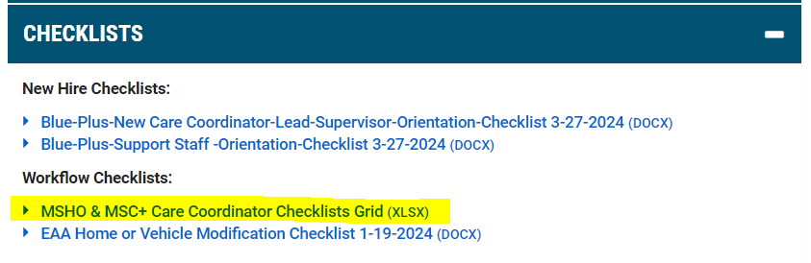
New guidance for use of the following PCP letters:
- The Support Plan Summary Letter – Intro to Primary Care Provider is the only letter Care Coordinators must send to the member’s PCP within 90 days of notification of enrollment and after Support Plan completion.
- We have renamed the Intro to Primary Care Provider letter to “Change in CC – Intro to Primary Care Provider Letter”. This should only be used when notifying the PCP about Care Coordinator changes.
- We hope this clears up any confusion between the use of the two PCP letter options.

If you have any questions, please contact your Partner Relations Consultant.

