Based on findings from our CMS audit, we have updated our TOC Logs which are now posted on the Care Coordinator website. The following changes include:
TOC Log Updates

- Update to instructions for “return to usual or new usual care setting required tasks:” If the Care Coordinator is notified of member’s discharge in advance, the CC must follow up and complete the TOC tasks outlined below within one (1) business day AFTER the actual date of discharge.
- Added documentation of “Support plan required updates”. If updates are identified for community members, CC must update/revise the support plan with any changes including both formal and informal supports. For nursing home members, confirm new or new usual care setting has discharge information in order to update facility care plan.
  - Checking Yes indicates an update was needed for medication changes, durable medical equipment (DME), service changes etc., resulting from a change in the member’s health status.
  - Checking No indicates the discussion with member/and discharge planner directs that no changes are required/requested to the care plan based on transition.

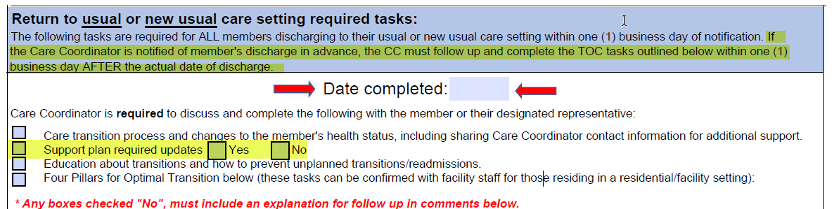

As a Care Coordinator, your involvement in transitions of care is designed to not only assist with the transition but is also paramount in assisting members to not be readmitted. Recent data shows there is an increase in readmission for our seniors. Discussing the transition home along with the “Four Pillars for Optimal Transition” with a focus on how and what can be done to prevent readmissions is truly valuable.

As a reminder, completion of the “Four Pillars for Optional Transition” tasks on the TOC log include:
- Timely primary care/specialty care follow up
- Medication self-management
- Knowledge of red flags that indicate a worsening in their condition and how to respond
- Use of a Personal Health Care Record

