DHS has brought to our attention that there are several “un-closed” open/complete MnSP EW RS plans in MnSP. Some MnSP EW RS plans were created in 2023. Blue Plus expects each delegate agency to log into MnSP, review and make every effort to “Close” any EW RS plans in “Open” and/or “Complete” status before 8/30/2024. You may choose to prioritize older MnSP EW RS plans and work your way to current open/complete MnSP EW RS plans.
MnSP Migration Clean Up
MnSP EW RS plans that are not moved to “Closed” status will not migrate to R MnCHOICES when MnSP retires on 9/30/2024. Reminder that members with existing MnSP EW RS Plans must also exist in the Revised MnCHOICES application for the historical PDF data to be loaded. Reference instructions below.
Please work with your staff to resolve and close any open legacy system MnSP forms.

Action steps for Persons with legacy system forms that are not in a closed status:
How to monitor your staff form statuses in MnSP:
- Log into MnSP and go to the My Plans Tab
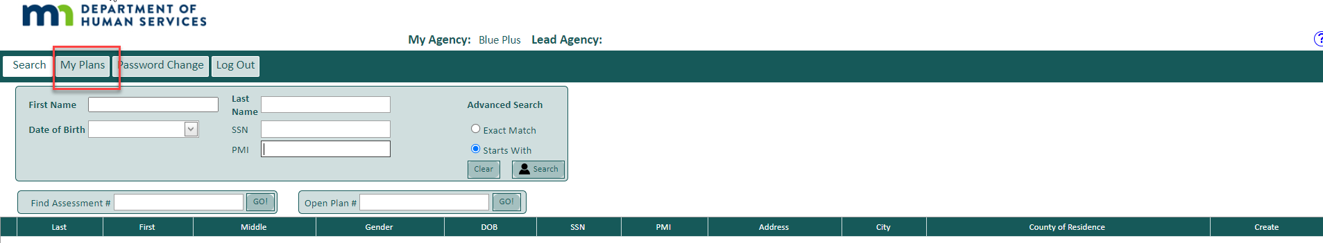
a. View and select: “My Agency”
b. Select form status “All”
c. Document Type: Select “All”

This will give you a list of open/complete forms. You can use the Plan owner search to monitor staff progress in closing open/complete EW RS Plans in MnSP no later than 8/30/2024.
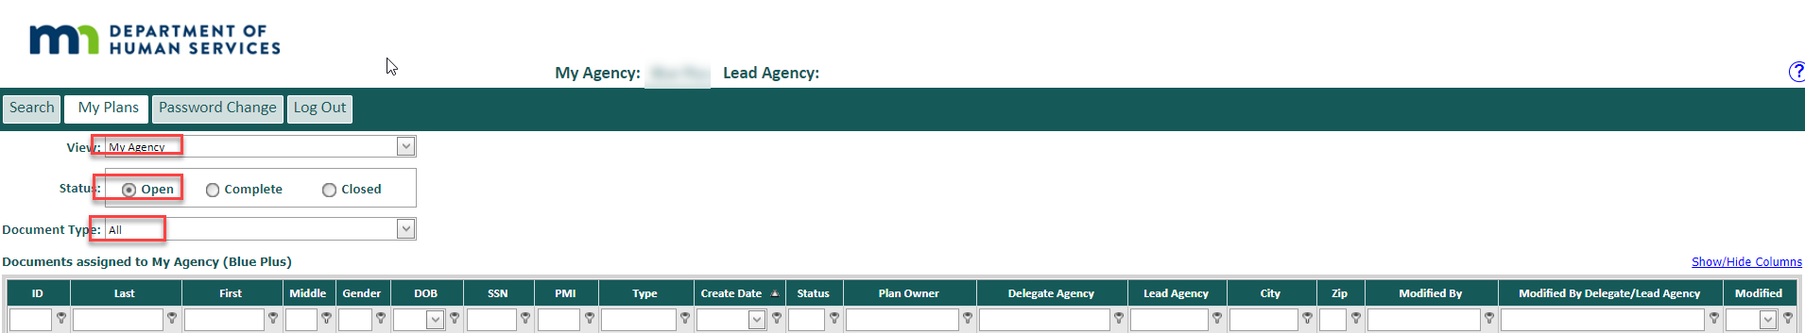
- Instruct your staff to review and move the status of MnSP EW RS plans (legacy forms) to a closed status.
- If the person record does not exist in the revised MnCHOICES application: Have your agency staff add the person record before 9/30/2024.
- The historical PDF will be loaded the next month.
Action steps for Persons with closed legacy systems forms but the person does not exist in the revised MnCHOICES application:
- Log into MnSP and go to the My Plans Tab
  - View and select: “My Agency”
  - Select form status “All”
  - Document Type: Select “All”
This will give you a list of open/complete forms. You can use the Plan owner search to monitor staff progress in closing open EW RS Plans in MnSP no later than 8/30/2024.
- Instruct Certified Assessors/MnCHOICES Mentors/Support Staff to log into the revised MnCHOICES application and create a person record.
- Use “+ Add New Person” and complete the required fields.
- MnCHOICES will show possible matches and allow staff members to import the data to MnCHOICES.
- If there is no match, add a new person and verify the PMI was entered correctly before selecting “Create.”
Important Reminder: Historical PDFs will be loaded to these person records in October 2024 when the above is completed prior to 9/30/2024. The last load of forms is October 2024.

Trouble shooting:
Action Steps if historical PDF does not load in the person records.
- Verify that the person’s previous MnSP EW RS plan is closed prior to 9/30/2024, and
- Verify the person’s record exists in the Revised MnCHOICES application prior to 9/30/2024, then
- Staff can have their MnCHOICES mentors use the MnCHOICES Help Desk Contact Form, DHS-6979 to submit their agency’s questions or concerns.
MnCHOICES Assessment & Support Plan Monitoring
It is our expectation that all delegate agencies will have a process in place to monitor timely completion of assessments and support plans ongoingly. If your agency does not have a process in place, please create one. Monthly monitoring should be done to avoid a backlog of open documents.

Please reach out to your Partner Relations Consultant if you have any questions.

