Partner Relations Team Government Markets
Manager:
Stormy Church

Consultants:
Kim Flom| Melinda Heaser| Cate Ness| Kim Pirkl| Wendy Schultz| Jill Scott| Ricky Vang

Partner Relations Team Government Markets
Manager:
Stormy Church

Consultants:
Kim Flom| Melinda Heaser| Sara Miller| Cate Ness| Kim Pirkl| Wendy Schultz| Ricky Vang

NEWS FROM BLUES

Dear Care Coordination Partners,

We’re excited to announce an expansion of the Odam Medical Group Mobile Clinic service area and program enhancements for 2024. The Mobile Clinic is a service through Odam Medical Group for our members enrolled in our public programs, including MSHO and MSC+ members.

The Odam Medical Group Mobile Clinic Program brings healthcare to populations in medically underserved communities in rural MN with goals to increase access to culturally concordant care, eliminate barriers to access and close gaps in care.

Please see attached slides which explains the program, service areas, FAW’s, and its enhancements including fall risk assessments, immunizations, medication management, bone density screenings, and mammograms.

Odam can see up to 10-20 patients each day in the following counties on Wednesday – Sunday.

- Becker
- Beltrami – new!
- Benton
- Cass
- Clay
- Crow Wing
- Kanabec
- Kandiyohi
- Meeker
- Mille Lacs
- Morrison
- Otter Tail
- Polk – new!
- Rice – new!
- Sherburne
- Stearns
- Todd
- Wadena
- Wright

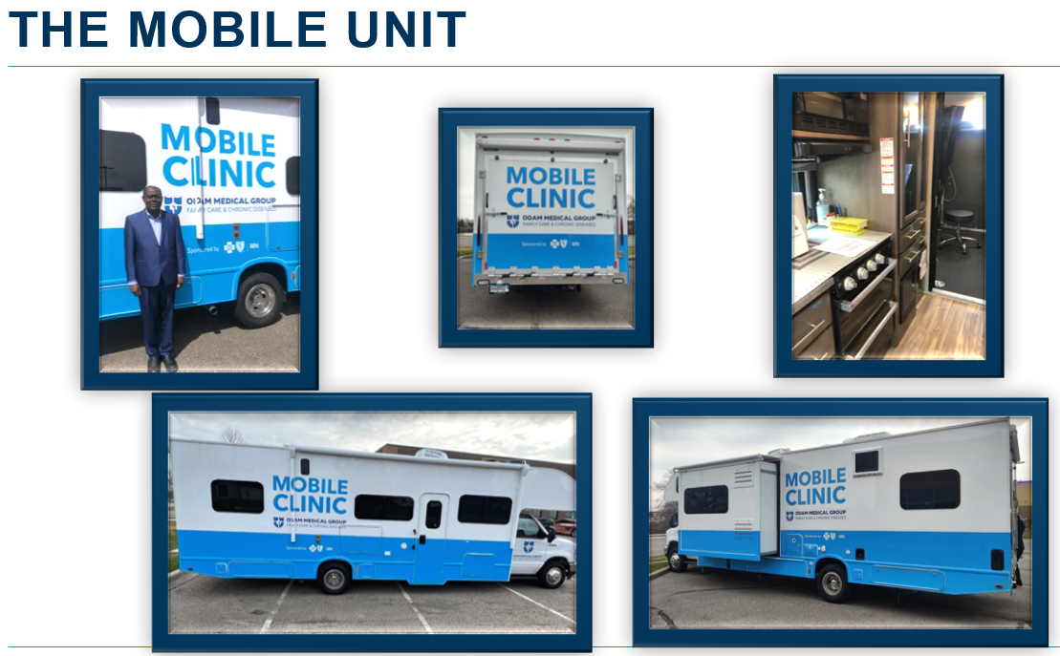

Blue Plus identifies members who reside in one of the service area counties who have certain gaps in care and have not been seen by a Primary Care Physician to address these gaps.

This is an FYI for Care Coordinators in the event a member reaches out to you about receiving outreach from Odam Medical Group. If the mobile staff identify any care coordination needs during the appointment, they will reach out to the assigned Care Coordinator.

Please reach out to your Partner Relations Consultant if you have any questions.

