Coming Soon: Medicaid Claims to Display in the Bridgeview Web Tool!
Bridgeview Updates
- Following an upcoming Bridgeview update, Claims will be an option within the web tool’s menu.

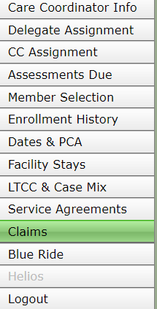
- When this feature is deployed, users will be able to access Claims by doing the following:
  - Log into Bridgeview.
  - Enter a member ID into the Member Selection box.
  - When the member’s details are displayed, you may then select Claims from the menu on the left.
  - After clicking Claims, the icon below will display:
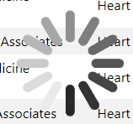
  - This icon indicates the web tool is retrieving claims information for you. Please be patient – pulling claims data can take a few moments.
  - Medicaid (MA State Plan services such as PCA, SNV, HHA) read-only claims data will be displayed in descending order, 20 claims per page, current year, plus one previous year.
  - Please refer to the table below for claims status definitions. *If you do not see a status listed for a claim, you may direct the provider to contact the BCBSMN Provider Support line at 1.866.518.8448.
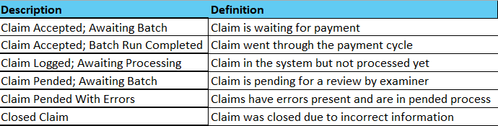

Fix to Bridgeview Defect Deploying the Evening of Monday, July 15th

A known defect following the last Bridgeview update has been identified and the fix will be deployed the evening of Monday, July 15th.
- This fix is intended to address an incorrect error message and users being unable to save entries for any NH assessments using form 6.15 or 6.28.01, when answering Completed in R-MnCHOICES with either yes or no.
- Before logging into Bridgeview on Tuesday, July 16th, be sure to clear your cache. Instructions can be found here. *To avoid data loss, check in any R-MnCHOICES assessments you may have checked out while working offline before clearing your cache.

Bridgeview alerts and updates about these upcoming changes will be posted on the Bridgeview page of our Care Coordination website. Please visit the webpage first to see if the info posted here addresses your question(s) or concern(s) before contacting the Bridgeview team at Bridgeview.Service.Agreements@bluecrossmn.com.

