During the COVID-19 pandemic, recipients on Medicaid maintained coverage without having to complete a renewal, and during the unwinding period, the Minnesota Legislature temporarily disregarded asset limits.
Asset Verifications to Resume for Some MA Renewals
- Starting with July 1st renewals, asset verification will return to the pre-pandemic practice of checking certain MA recipient assets at the time of application, at renewal, and between renewals if there is a change reported to an existing, countable asset.
- The following MA recipients may be subject to asset verification and must meet the asset limit to maintain eligibility:
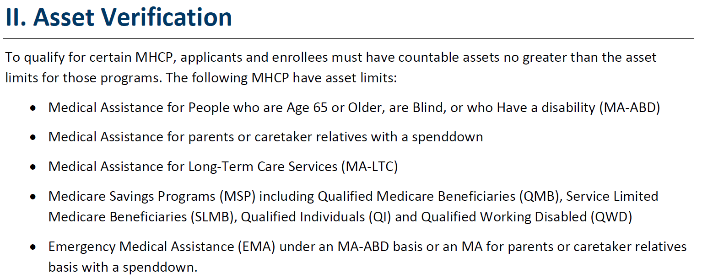
- Asset limits depend upon the program, and assets may be reduced (spent down) to maintain eligibility. For specifics, please consult with a Financial/Income Maintenance Worker or review DHS-3461A.
- A person’s home that they or their spouse live in, one vehicle, and personal items do not count as assets.
- Assets subject to verification include but may not be limited to the following:
    - Checking/Savings Accounts (open and recently closed)
    - Money Market Accounts
    - Certificates of Deposits
    - Stocks and Bonds
    - Trusts
    - Mutual Funds
    - Real Property (ownership of parcels of land, structures, buildings, house, etc.)
    - Vehicles over the limit of 1
    - Other Financial Accounts
- Impacted enrollees will receive a DHS notice in the mail about two months before their renewal month, notifying them that assets will be counted at their upcoming renewal, and that they will be required to provide proof of assets.
- The following proofs may be required, depending upon the member’s situation:
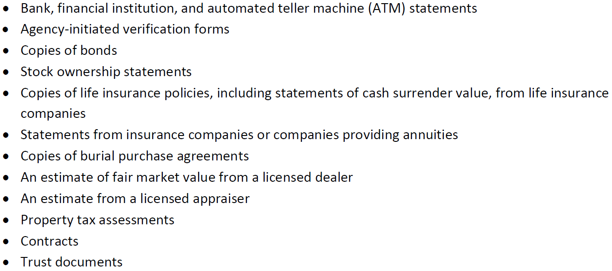
- If members do not supply proof of assets when completing renewals, their eligibility determination may be delayed, and they may term for procedural reasons.

Potential Impacts to Care Coordinators
Care Coordinators play an important role in the MA Redetermination process.
- Members may be confused by needing to provide proof of assets at renewal, and Care Coordinators should be prepared to assist them in connecting with their Financial/Income Maintenance Worker to address any questions/concerns.
- Know when your members will need to renew their Medical Assistance. One way to do this is by utilizing DHS’s MA Renewal Look-up Tool.
- Encourage members to look for DHS mailings, to carefully review this information, and to return renewal application timely and with required proofs, as applicable.
- Assist members, as needed, in obtaining copies of proofs and submitting proofs to their Financial/Income Maintenance Worker.
- If a member requires transportation to attend an in-person meeting with a Financial/Income Maintenance Worker or a Navigator, BlueRide may be an option.
- Review the updated Renewal Tips for Care Coordinators for additional information and guidance saved on Blue Plus’s MA Redeterminations Page.
- Refer to DHS’s department news release for additional details.

