Authorization of RN T1030 and LPN T1031
Currently when authorizing both LPN (T1031) and RN Skilled Nurse Visits (T1030), two separate service agreements must be entered into Bridgeview based on provider staffing and member need.

If the provider is requiring an adjustment in the ratio of RN and LPN as currently authorized, there are system, claims and tracking limitations that do not allow for units with separate codes to be moved flexibly without Care Coordinator/Case Aides changing the service agreements in Bridgeview.

New Process:
If the provider is requesting an adjustment in the ratio of RN and LPN currently authorized, Care Coordinators/Case Aides must modify the current service agreements in Bridgeview to match the provider’s requested change. When making the changes to the original service agreements, the Care Coordinator/Case Aide must add a description to the Service Authorizations affected. These changes will then be entered into Helios by our Utilization Management team.

For example:
Current authorization span: 1/1/2024 – 12/31/2024
Two authorizations in Bridgeview and Helios include:
- 32 units LPN T1031 1/1/2024 – 12/31/2024
- 20 units RN T1030 1/1/2024 – 12/31/2024

Provider calls the Care Coordinator on 9/1/2024 to say they have used all RN visits and need 2 more T1030 RN visits for the rest of the authorization span.

In Bridgeview, the CC would modify the original service authorizations to include:

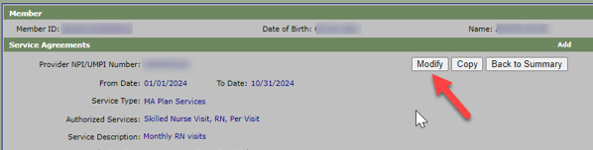

- 30 units for LPN T1031
  - Add in Service Description: Technical Change per provider on 9/1 request to move 2 visits to RN No DTR required.
  - Provider Reason Code 10: THIS IS A NEW SERVICE AUTHORIZATION

- 22 units for RN T1030
  - Add in Service Description: Technical Change 9/1/2024 moving 2 visits from LPN to RN
  - Provider Reason Code 0150: THIS IS A REVISED SERVICE AGREEMENT THAT HAS INCREASED THE TOTAL UNITS AUTHORIZED.
The provider is now allowed to provide up to the number of units and total authorized amount shown on this authorization.

