RMnCH Updates and Frequently Asked Questions
As previously communicated, as of July 1st, all Delegates must be prepared to complete all assessments in the Revised MnCHOICES application, except for nursing home related assessments.
Members open to other waivers (non-EW)
For members on a non-EW waiver (i.e., CADI, DD, etc.), the Care Coordinator should only assign themselves as a Care Coordinator in R-MnCHOICES. Do not assign as certified assessor. This guidance is also included on our R-MnCHOICES Blue Plus FAQ (located on the Care Coordination website under the Revised MnCHOICES tab/page).

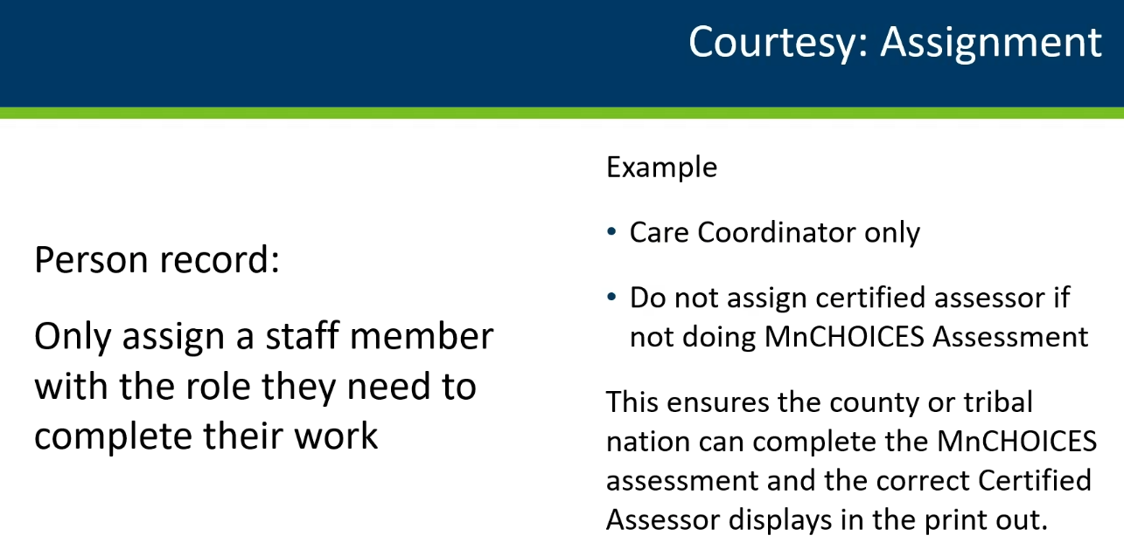
Members residing in Customized Living
For Current Living Situation, the Care Coordinator must select “Resides in own home or apartment”. Do not select “Resides in community-based congregate setting” until DHS instructs otherwise. When selecting response for Current Living Situation as “Resides in Own Home”, it will populate options for who they live with, Care Coordinator should select “Alone”.
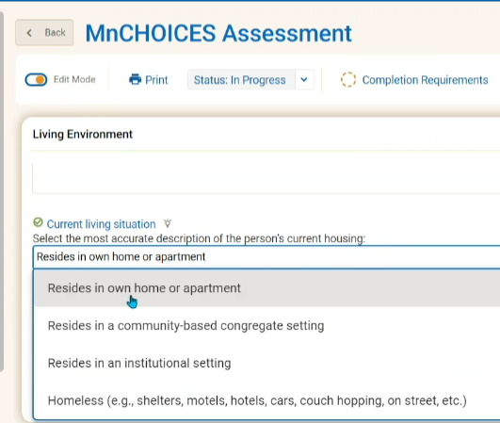

Support Plan Revisions
When making plan revisions, regardless of assessment type, Community Well or Elderly Waiver, Care Coordinator must use the support plans Previous Effective Date Range.
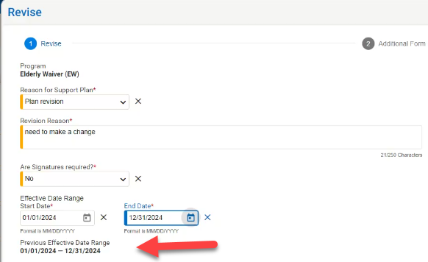

Updates to the Support Plan Process Change:
Previous guidance: Support plan revisions were not required for mid-year, goal update/outcomes or member check-ins throughout the Support Plan year for members with an active Plan Approved Support Plan. Care Coordinators were only required to complete a Support Plan revision for an active Plan Approved Support Plan when there were changes to the members’ services (including DME), service frequency, service units and/or service providers. All other changes should have been documented in a progress note for support plans completed in the Revised MnCHOICES application.
New guidance: For members with an active Plan Approved Support Plan, plan revisions are now required for all goal changes and monitoring in addition to previous requirements when there are changes to the members’ services (including DME), service frequency, service units, and/or service providers.
Support Plan revisions require obtaining a new member signature when there are changes in services and supports, Care Coordinator must indicate this on the Support Plan revision. A copy should be provided to the member/legal representative.

Introductory Letter/Assessment Summary
The MnCHOICES assessment summary must be mailed to members and/or their legal representative within 60 days of the assessment. Refer to MnCHOICES Revision Assessment and Support Plan Documents and Reports & DHS Questions Asked by MCOs about the launch of the Revised MnCHOICES Application for more details. The Introductory Letter/Assessment Summary Date Sent field is now a required field.

If you choose to wait to send the Introductory Letter/Assessment Summary with the Support Plan, you will need to complete these additional steps within 30 days of the assessment timeline:
- When the assessment is complete, enter the date of the assessment as the Date Sent, then move the assessment status to “MMIS Ready” this ensures all necessary data and eligibility information populates correctly to the support plan.
- The support plan status should be “In Progress – Assessment Complete” for the assessment data to pull into the Support Plan (includes EW RS Tool in support plan if applicable).
- Once you have completed the Support Plan and are ready to send the Introductory Letter/Assessment Summary and Support Plan to the member/legal representative, update the Introductory Letter/assessment summary Date Sent field to reflect the date both the Introductory Letter/Assessment Summary and support plan is sent.
To make this change: move the assessment status to “Pending MMIS Review”. Then move the assessment status to “Request Clarification”, this will bring your assessment status back to “In Progress” and allow you to edit/update the “Introductory Letter/Assessment Summary Date Sent field.
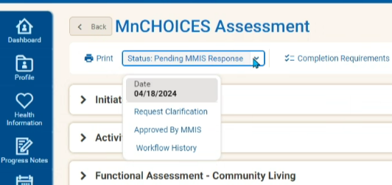
- Then move the assessment status to “MMIS Ready”.
- When the assessment is final, move the assessment status to “Approved in MMIS” (no changes can be made after an assessment is moved to the final status).

Language Block Attachment Requirements
When mailing members/legal representatives an assessment summary and/or support plan/support plan revision, include the appropriate Blue Plus MSHO or MSC+ Language Block insert. This is located on the Care Coordination website under the Care Coordination tab.
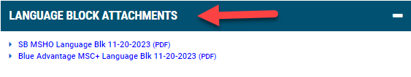

Transitions of Care and Revised MnCHOICES
If the member has had their assessment completed in the Revised MnCHOICES application and has not had a change in their services (including DME), service frequency, service units, and/or service providers, a support plan revision would not be required. Care Coordinators should document on the TOC log, optional Care Coordinator may also choose to document in the member’s case notes.
- Currently, it is not required to attach completed TOC log(s) to the members file in the Revised MnCHOICES application, however, one may choose to and clearly label the attachment.

Unable to Reach and Refusals completed and documented in the R- MnCHOICES application
A Screening Document is not required to be entered into MMIS. Attach a copy of the UTR Member Support Plan Letter/Refusal Member Support Plan Letter to the member’s profile under attachments in the Revised MnCHOICES application.

Transitional HRA’s completed and documented in the R-MnCHOICES application
TRHA’s do not require a Screening Document to be entered into MMIS. Continue to complete the required 6.28 THRA form regardless of whether documenting in the Revised MnCHOICES application or not. Attach a copy of the 6.28 THRA to the member’s profile under attachments in the Revised MnCHOICES application when the assessment (is completed in the Revised MnCHOICES application.

Weekly Metric Reports
DHS sends all Lead Agencies a weekly Revised MnCHOICES metric report. If your agency is not a Lead Agency and would like a copy of these weekly metrics, please reach out to your Partner Relations Consultant.

