To avoid any gaps in waiver coverage, Care Coordinators must confirm the actual date of the in-person assessment when determining your next annual reassessment date for new enrollees.
Validation of in-person HRA date and waiver spans for new enrollees

There may be scenarios where a member had an eligibility update for EW open (MMIS activity type 07 or 09 with assessment result 01 or 11) and the member may be due for their reassessment a lot sooner. An eligibility update may be noted on the Support Plan as the “Assessment Date” and should not be used for determining reassessment date.

Scenario #1:
For this new enrollee, the support plan had an assessment date noted as 2/15/2023 which was an eligibility update to open the member to EW. The in-person Mn-CHOICES assessment was actually completed on 12/6/2022. Therefore, the waiver span end date would be 11/30/23 and the next in-person assessment would need to be done in November.

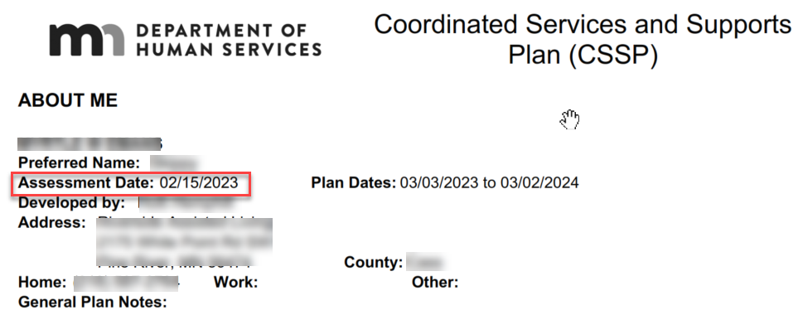
The only way to verify when this reassessment will be due is to confirm when the last in-person assessment (MMIS activity type 02 or 06) was completed. This information is also necessary to know so that CC is following DHS Remote Assessment Policy and Blue Plus Care Coordination Guidelines, as applicable.
Eligibility updates (MMIS activity type 07 and/or 09 in MMIS) documented in MnCHOICES may have misleading dates on the CSP/CSSP/support plan.

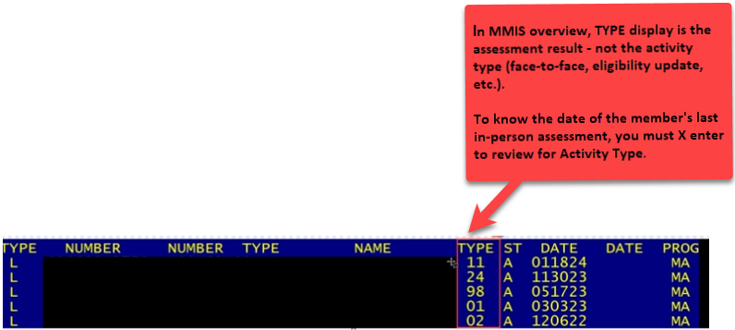

Below is a SD Activity Type 9 - Eligibility Update, opening member to EW. Do not use this activity date and/or effective date to determine the member’s annual reassessment.

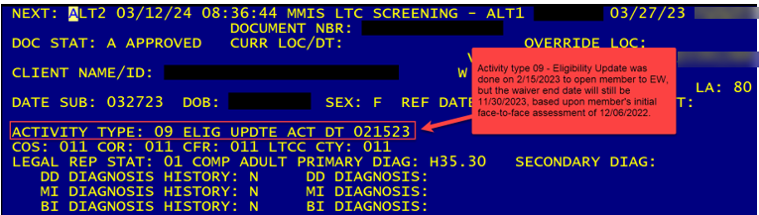
In the below example, member’s last in-person assessment was done 12/6/2022, and was opened to Elderly Waiver via Eligibility Update on 2/15/2023, with waiver ending 11/30/2023. Therefore, the Care Coordinator must complete a reassessment before the end of November 2023 to meet both the 365 requirement and before waiver end date of 11/30/2023. Reassessment SD should be entered into MMIS prior to the end of November 2023 and before Blue Plus Cut Off date, with an effective date of 12/1/2023.

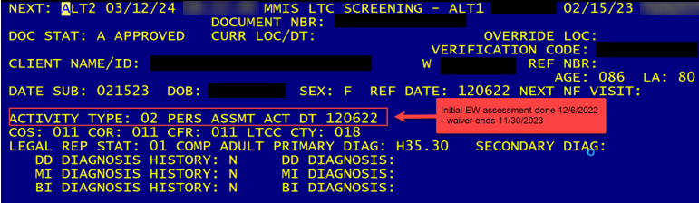

Bridgeview Member Selection – Member Detail section also includes waiver end date:
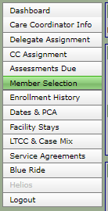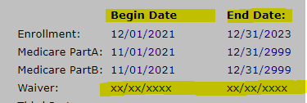

*Note this includes all waiver end dates, which includes elderly waiver. Dates in Bridgeview will only be as accurate as the information in MMIS. If the SD opening/reopening the waiver (elderly waiver for our members) has not been entered into MMIS or missed the DHS cut off dates, this field may not be accurate.
Care Coordinators must verify the waiver span and 365 timelines in MMIS and Bridgeview.
- Dates in MMIS, Bridgeview, and transfer documents should match for waiver end date. If not, additional research is needed. Contacting the previous lead agency to clarify discrepancies may be warranted.
- Members may be transferred to Blue Plus with an initial in-person assessment completed prior to an eligibility update. Use the date from the last MMIS activity type 02 Face to Face assessment SD entry to determine the reassessment date.
- Members opening (MMIS assessment result 01) or reopening (MMIS assessment result 11) to the waiver may require an earlier reassessment date from their last activity type 02 Face to Face assessment SD activity date.

Scenario #2:
Member is enrolled in another health plan and requests MA State Plan Services only, such as PCA/CFSS services. At the time of assessment, the member also met nursing home level of care but declined elderly waiver services.

Less than 60 days later, member requests to add an elderly waiver service, such as homemaking. The Care Coordinator works with the member and financial worker to complete the necessary process to remove the U Code and enter the screening document (SD) to open to EW. Shortly after, the member enrolls in Blue Plus.

Timeline of error:
- 4/10/2023: In-person assessment completed by other plan, MMIS activity type 02 Face to Face with assessment result 02 (remain in community with services not funded by *waiver program) and program type 18 (MSHO & MSC+) was entered.
- 4/24/2023: Member requests addition of HM services to be added. Secured HM provider to staff hours needed starting 5/1/2023.
- 05/01/2023: An eligibility update, MMIS activity type 07 and assessment result 01, is entered to open to the waiver for the first time with an effective date of 05/01/2023. Existing waiver span is 5/1/2023 – 3/31/2024.
- 6/1/2023: Member enrolls with Blue Plus and case is transferred to a Blue Plus delegate.
- 6/10/2023: The Care Coordinator reviewed the transfer documents and the last MMIS assessment history done on 5/1, and incorrectly believed the last in-person assessment was completed on 5/1/2023 (eligibility update SD date).
- Care Coordinator assumes the reassessment is not due until the end of April 2024 and waiver span ends on 4/30/2024, when reassessment was actually due before the end of March, and waiver expired 3/31/2024.
- When trying to enter April reassessment in MMIS, Care Coordinator received an edit that says No Matching Waiver Segment. This means an assessment cannot be entered (activity type 06 with assessment result 13) to continue the same program.

What should have happened:
- Care Coordinator should have reviewed both MMIS (entries) and Bridgeview to confirm the last in-person assessment and current waiver end date.
- For member’s Blue Plus enrollment in June, Care Coordinator should have completed a Transitional HRA and entered the last in-person assessment date of 4/10/2023 (not eligibility update of 5/1/2023) into Bridgeview selecting, Fee-For-Service/Reviewed HRA as the HRA Form Used to establish the correct 365-day timeline.
- Care Coordinator should have completed the reassessment in March and entered screening document by cut-off date of 3/21/2024 (for new waiver start date of 4/1/2024).

