MSHO Supplemental Benefits Updates
Flex Card – NEW Merchant Codes Accepted
We have added the following merchant category codes to the approved list:

5983 Fuel Dealers – Fuel Oil, Wood, Coal, and Liquefied Petroleum
- This code will allow propane sellers who have this merchant code to accept the debit cards

We are working on adding the following rent code for customized living facilities:
8050 Nursing, Home Healthcare and Personal Care Facilities
- Customized living facilities who accept Visa may be registered with this merchant code. Members who live in customized living and would like to try to use their debit card for their rent may contact their landlord/facility to see if they can take the debit card under this merchant code.

Flex Card – Calling CVS Customer Service
If you or a member need to call CVS to ask questions about the flex card, call 1-855-788-3466.
- Press 1 for English, 2 for Spanish
- Follow the prompts for ‘calling about a lost or stolen card or have never received a card’. Press 1.
- You will then be transferred to the CVS customer service line for assistance.
CVS Customer Service Agents continue to receive additional training for assisting SecureBlue MSHO members with their flex card. If you hear that a CVS Customer Service Agent provided incorrect info to your member (i.e. told the member they could use the debit card for OTC items, use it at retailers like Walmart or Dollar General, etc.), please email Jenna.Rangel@bluecrossmn.com with the member name/ID and date member spoke to CVS, if available.

CVS – Online and App Resources
CVS has 2 different websites and apps members can use for their OTC and flex card benefits.
- OTC benefit
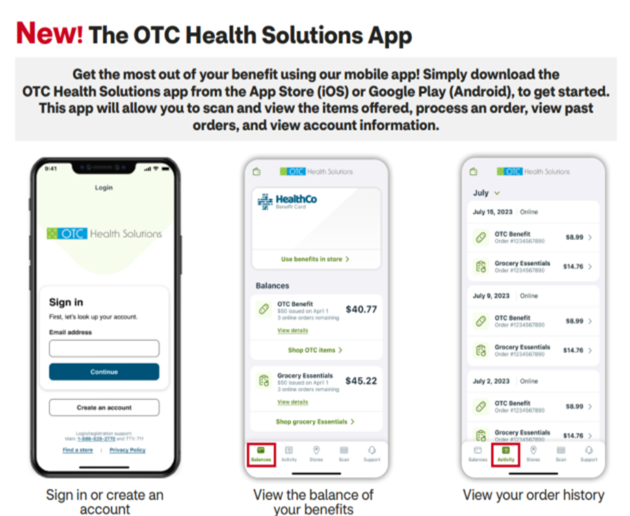
Website: :https://www.cvs.com/benefits
App: OTC Health Solutions app
Members can use the website or app to check OTC balances
scan and view eligible items, place and track orders and
see transactions.

- Flex Card for household supports benefit
Website: www.mybenefitscenter.com
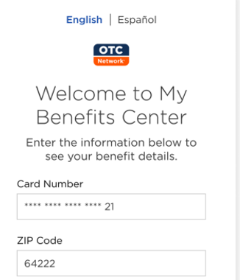
App: OTC Network app.
Members can use the website or app to activate their card,
check balances and see transactions.

Living Arrangement updates
Because eligibility for many of the SecureBlue MSHO supplemental benefits is dependent on the member’s rate cell, if the member has a change in living arrangement (i.e., moves permanently in or out of a nursing facility), please make sure to notify the financial worker via DHS 5181 as soon as possible. This will help to ensure members are correctly identified for benefits that are limited to a specific living arrangement. You may also manually update the members’ living arrangement in Bridgeview. This temporary manual Bridgeview update will remain in Bridgeview for up to 90 days until the financial worker makes the change.

qMedic – New training resource for care coordinators
qMedic has a short training video available for Blue Plus care coordinators on SecureBlue MSHO supplemental benefits offered through qMedic (PERS, Blood Pressure Monitoring and Companion Pets). https://www.youtube.com/watch?v=tNge7pWdamw

Secure/Encrypted emails and referrals
REMINDER: Emails that include member PHI, including referral forms, should be sent securely or encrypted. Supplemental benefit providers are instructed not to accept emails with member PHI that are not secure or encrypted.

Save the Date March 26th 2024 10-11:30am
We will be having a 2nd SecureBlue MSHO supplemental benefits training on March 26th at 10:00. This training is a follow-up to the training that was provided on Jan 4th 2024 which focused only on NEW benefits. This second training will include benefits that were offered in 2023 and carried over into 2024. The webinar will be recorded for those unable to attend.
