- State Plan Home Care (PCA, HHA, SNV) authorization file is sent from Bridgeview to Utilization Management (UM) daily for data entry into Helios.
Helios—State Plan Home Care Auth Updates
- UM has 10 business days from the date of the Bridgeview file to enter authorizations.
- If a provider is asking about an authorization (also referred to by the UM team working in Helios as PA or prior auth), first check the date you entered the SA into Bridgeview by hovering over the green view arrow.
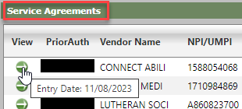
When the SA was entered into Bridgeview 10 or more business days ago, then you can check Helios – Utilization Management for the authorization number.
Navigating Helios:
- After logging into Helios, click ADMIN.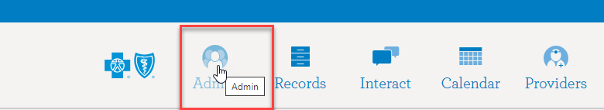
- To access Authorizations, click Utilization from the menu on the left.
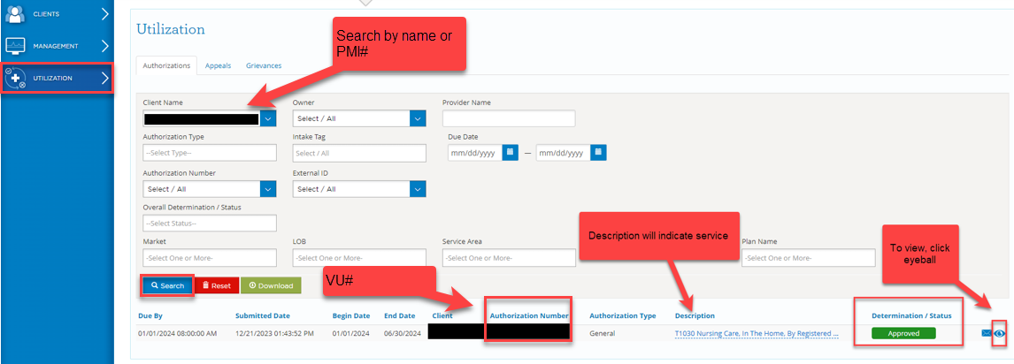
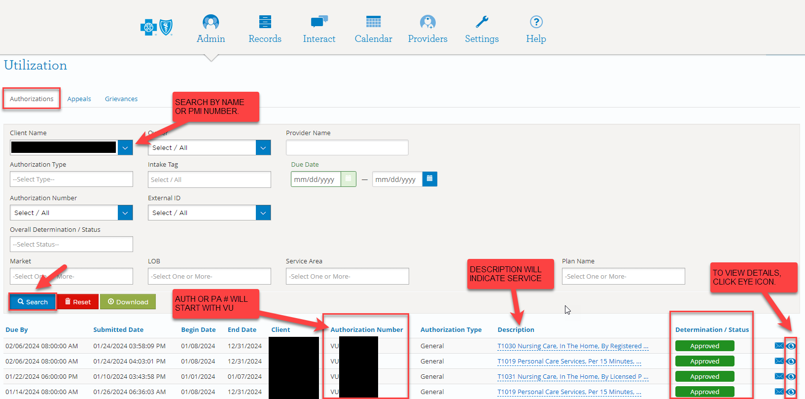

- In Client Name field, enter member’s name or PMI#. Click SEARCH.
- If the member has authorization(s), a list will display below the search criteria. In the above example, the member has four authorizations.
- The following information will display:
  - Begin/End Date, Client name, Authorization Number, Authorization Type, Description, Determination/Status (approved, voided, pended, denied).
- To view details and a copy of the authorization, click the EYE icon to the far right.
- In member’s record, scroll down to Related Correspondence.

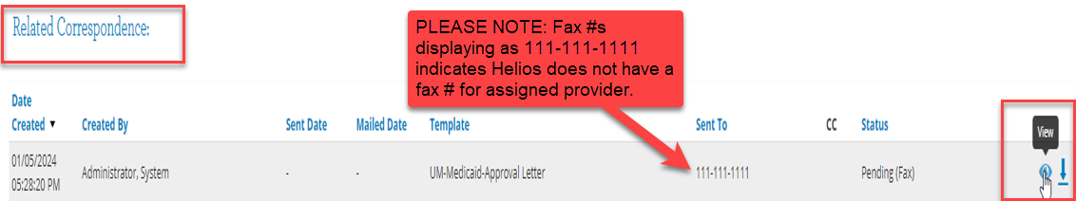
- Provider(s) will receive a mailed copy of their authorization(s).
Note: Authorizations (or PAs) can also be faxed to providers if the fax number is included in the Service Description field of the Bridgeview Service Agreement. If Care Coordinators include the fax number in this field, UM will add the provider’s fax number and the authorization will be faxed (as well as mailed) to the provider.
- If Helios does not display authorization information and it has been 10 business days or greater since Bridgeview entry, take a screenshot of the Bridgeview Service Agreement and securely email your Partner Relations Consultant. Your PR Consultant will work with Bridgeview Service Agreements staff and UM staff to resolve this.

Tips for Assisting Providers
- When providers reach out regarding an authorization number, Care Coordinators can give them the VU Authorization Number found in Helios.
- If the provider requires further assistance, CCs can direct them to call Provider Services at 866-518-8448.
- Blue Plus is currently working on reported authorizations that did not include service codes, description, units, and NPI/UMPI numbers. If Care Coordinators are aware of authorizations that are missing the above information, please email your Partner Relations Consultant.
- Providers must always use the new Subscriber ID. (MQG MSC+ or MQS MSHO with 8+PMI) for all services regardless of date of service.
- When Providers bill in 2024, they should use new payer ID 00726 even if for dates of service (DOS) in 2023.
- Providers will not get a new authorization letter or fax from Blue Plus for an authorization that had been previously sent out by AGP for service start dates in 2023.
- Providers can continue to bill off the authorization number they received from AGP. If Provider is unsure what authorization number to use, CCs can give them the one found in Helios. Provider can bill for dates of service in 2023 or 2024 as authorized and claims will pay.
- As a reminder, providers can be sent to the Blue Cross website for information on the migration. https://www.bluecrossmn.com/providers/migration-minnesota-health-care-programs-mhcp

