January 2024’s renewal roster has been updated with an additional column titled RENEW_STAT.
Renewal Roster Update
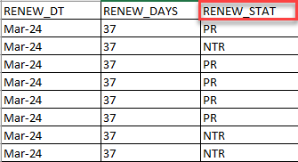
- RENEW_STAT codes:
    - Code PR – Passive Renewal (ex parte). Members identified as “PR” were found to be eligible to be renewed under the ex parte process. They will or have received renewal notifications but are not required to complete and return the renewal form to retain eligibility.
    - Code NTR – Need to Renew. Members identified as “NTR” are not able to be processed under the ex parte process, and the renewal form must be completed, returned, and processed prior to the RENEW_DT to determine eligibility.
- When conducting Renewal outreach, Care Coordinators should prioritize members flagged as “NTR.”
- Outreach should still be completed to members whose renewal status is flagged as “PR.”
  - If member states they received DHS paperwork, indicating they need to complete/return the renewal form, CCs should assist in verifying their renewal status by contacting a Financial or Tribal worker. Care Coordinators, with member(s) remaining on the call, can also reach out to a MNSure Navigator.
- Please review updated Renewal Tips for Care Coordinators, saved on the MA Redeterminations webpage, for additional important information and guidance.

