CMS legislation changes now require us to send monthly EOB summaries to our MSHO members. The summary will show monthly claims that have been processed. The notice does state THIS IS NOT A BILL and will show $0 under the “Amount You Owe” column.
MSHO Explanation of Benefits (EOBs)
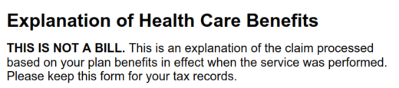
EOB summaries will be sent monthly only to SecureBlue MSHO enrollees and does not include members on MSC+.
We have attached a blank Explanation of Health Care Benefits summary as an example.
Thank you.

