As previously communicated, Utilization Management (UM) is one of the functions now operating in-house (formally AGP) since the start of 2024.
DTR Update
- When DTRs are processed by UM, Care Coordinators will receive a faxed or emailed copy of the letter sent to the member and provider(s).
  - The fax number provided by CCs on the DTR form will the fax number UM will fax a copy of the letter to.
  - This process replaces AGP’s practice of emailing Care Coordinators a date that Service Agreements should be ended in Bridgeview.
- The letter Care Coordinators will receive includes an “Effective Date of Action.” Service Agreements should end 1 day prior to this date.
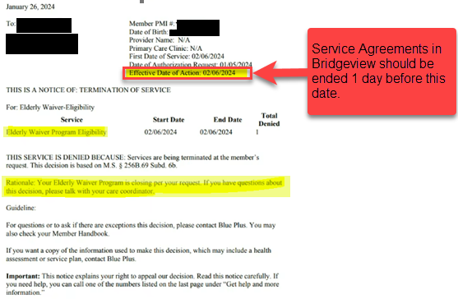

Questions about DTRs? Email your Partner Relations Consultant.

