As previously communicated, Utilization Management (UM) is one of the functions now operating in-house (formerly AGP) since January 1, 2024.
Denial Termination Reduction (DTR) Update 2-2-2024
- When DTRs are processed by UM, Care Coordinators will receive a faxed or emailed copy of the letter sent to the member and provider(s).
  - The fax number provided by CCs on the DTR form is the fax number UM will use to fax a copy of the letter to the CC.
  - This process replaces AGP’s practice of emailing Care Coordinators the date that Service Agreements should be ended in Bridgeview.
- The letter Care Coordinators receives includes an “Effective Date of Action.” Important: Service Agreements should end 1 day prior to this date.
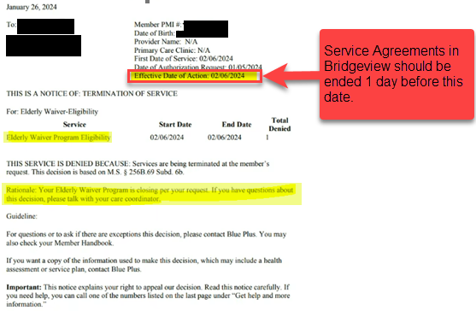
DTR Update 2-16-2024
*We are aware of CC’s not receiving DTR’s by fax. If you did not receive a DTR response or have any questions about DTR’s, securely email your Partner Relations Consultant with the details.*

How to find DTR letters in Helios:
- Click on Admin.
- Click on Utilization
- In Client Name – enter Member Name or PMI
- Click “Search”
- Click on the view icon

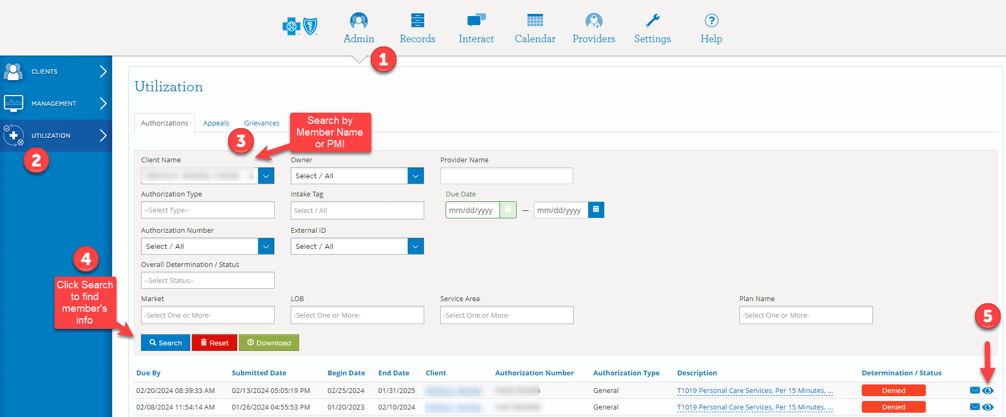

- Scroll down to Related Correspondence and choose to either view or download:

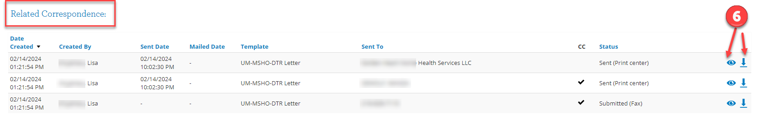
You will then be able to view the “Coverage Decision Letter” sent to the member, provider, and Care Coordinator: