### 

### Objective: To provide guidance to the navigation of Records in the Care Manager Portal

**Location:** Records

Details

In the Care Manager portal, clients/members can be manually or automatically, through system configuration, added or removed from a user's panel. Having a client/member on a user's panel allows that user, based on role and access configuration, to have access to specific client/member record information.

Users can identify a client/ member on their panel by navigating to the Admin/Clients section of the platform and locating the client/member. To the right of the client's/member's name, users will see either a red or blue icon.

* The "Red Person" icon indicates that the client/member IS on the user's panel
* The "Blue Person" icon indicates that the client/member is NOT on the user's panel.

Users can add clients/members to their panel by clicking on the blue person icon.

Once selected, the blue person will turn red indicating that the client/member has successfully been added.

Many functions and areas of a client's/member's record will only be available if that client/member is on the user's panel including; however, not limited to:

* + Face sheet hyperlinks
  + Full face sheet information
  + Member/Client record including associated tasks, episodes, activities, assessments, medications, diagnoses
  + Providers and Provider Directory

Users can remove clients/members to their panel by clicking on the red person icon. Once selected, the red person will turn blue indicating that the client/member has successfully been removed.

Member Record

Members who are on a user’s panel will be available for selection in the dropdown list in the Records tab.

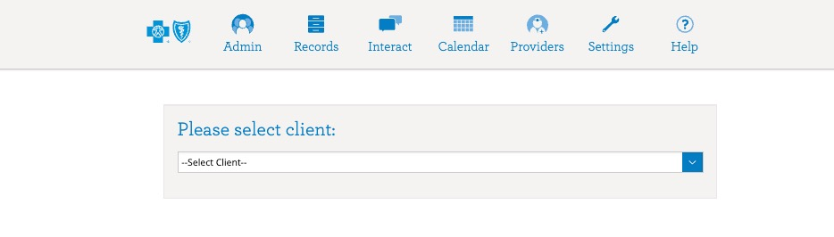

Health Summary Tab

Once a member is selected, the member’s Health Summary screen will appear. Users can confirm they are in the correct member record by viewing the member name that appears in the top right corner of the platform. The “i” icon next to the member name will offer a view of the client info box. The modal window provides users with demographic information, quicklinks, and health plan information at a glance.

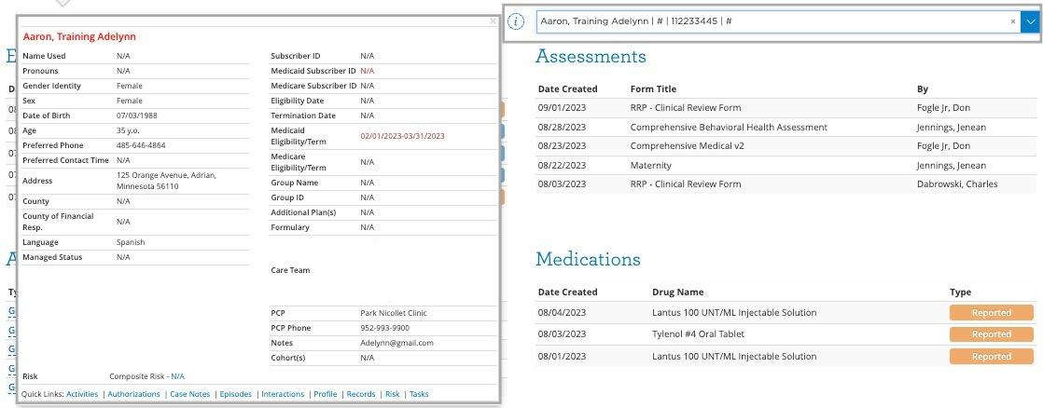

The Health Summary screen will give the user initial information regarding items such as:

* Tasks
* Assessments
* Authorizations
* Medications
* Episodes
* Providers
* Diagnoses

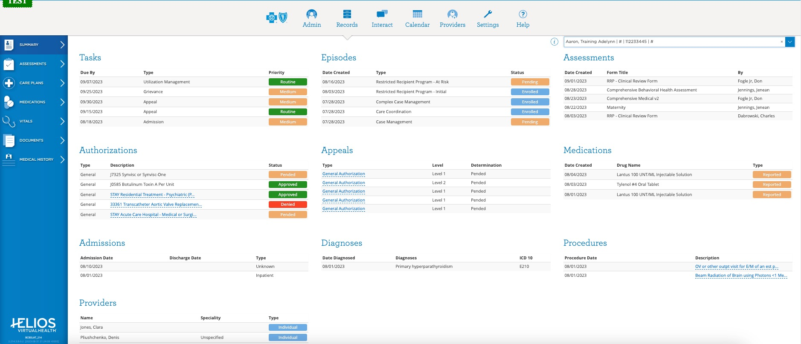

Note: Details available in each window, or widget, will include the five (5) most recent elements.

Each window/widget on the health summary page offers the user the opportunity to navigate quickly to that area; the member’s name will automatically appear, if applicable to the area, in the filter dashboard and populate results specific to the member.

Assessment Tab

The Assessments tab offers users the ability to view assessments that are currently:

* “In-Progress”, assessments that have been started; however, not yet submitted/completed.
* “My Assessment”, assessments that were completed by the user. Assessments in this area will allow the user to view, print, export, and/or duplicate.
* “All Assessments”. offers a full list of assessments that have been completed by any user. This area also allows users to view, print, duplicate, or, if applicable, view associated Interactions.

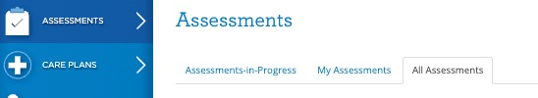

Each assessment offers the user the opportunity to click on the assessment name which then prompts the population of the assessment to the right of the screen.

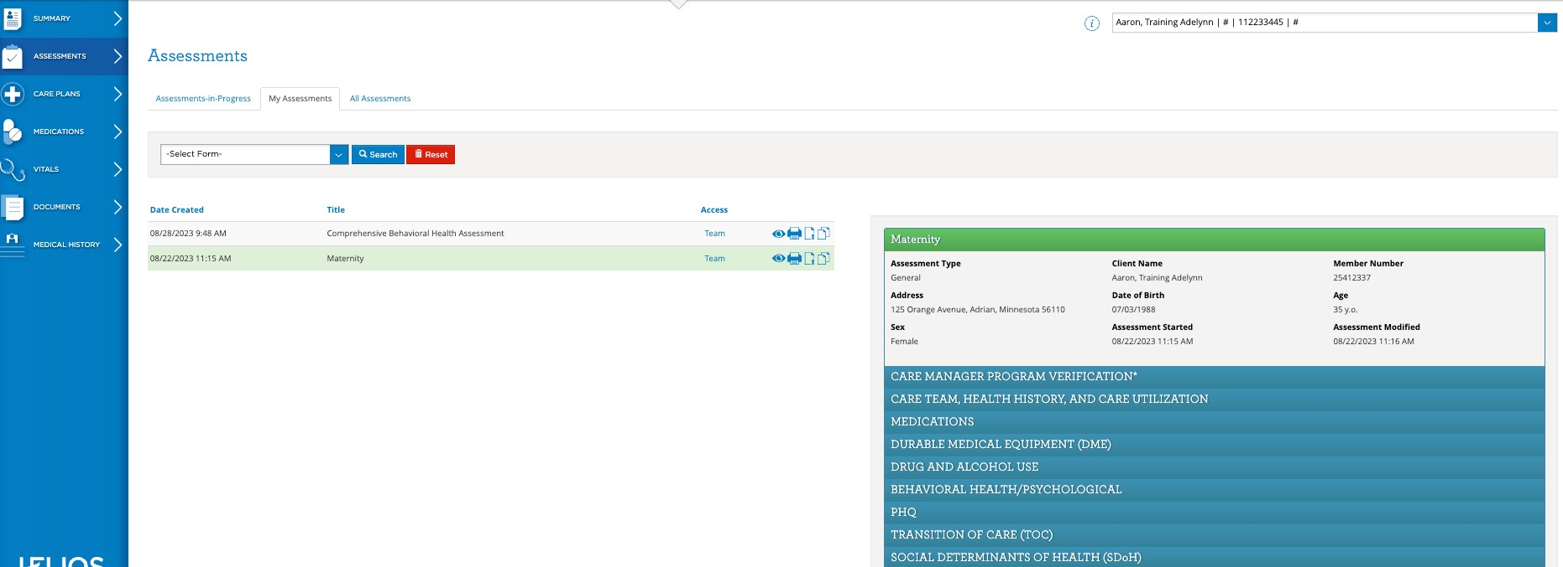

Care Plans Tab

The system allows for the automatic population of internal care plan value sets based on configurations

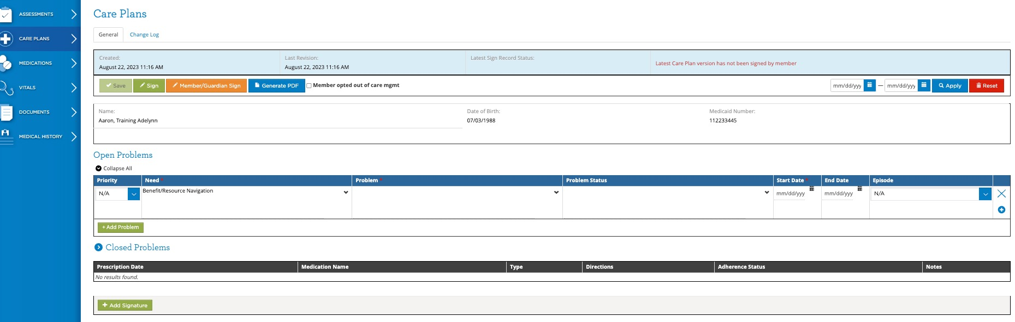

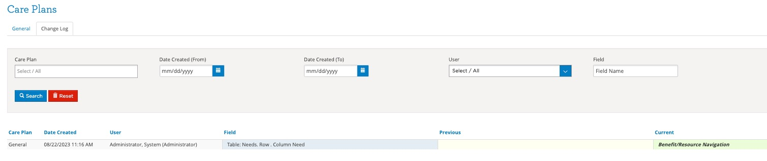

Medications Tab

Given the importance of Medications, they are given their own dedicated view in the Records section. The Medications view shows the list of both current and prior medications documented for the selected member. Each Medication contains a list of fields:

* Drug Name and NDC #
* Prescribing Provider and Pharmacy
* Type and Source indicate the origin of this medication entry in the member record.
* Dose / Route / Frequency describe how the medication is supposed to be administered.
* Date Prescribed and Last Filled Date are the dates on which the medication was prescribed and the last time it was filled by the pharmacy, respectively.
* Quantity, Number of Refills and Days Supply are data elements that speak to the amount of medication available to the member.
* Reconciled is a documentation field for the Blue Cross Internal Care Manager that indicates whether the Care Manager has independently verified this specific medication with the member.
* Adherence Status indicates whether the member is adhering to the prescription.

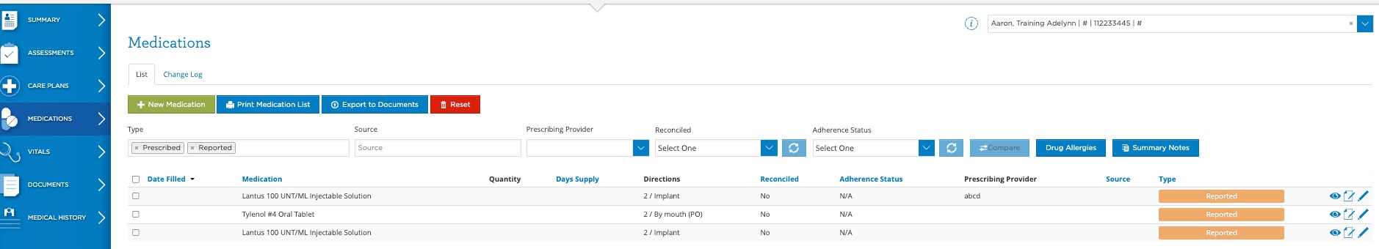

Documents Tab

The Documents tab holds information both generated in HELIOS and externally.

The Clinical tab holds a number of document types including: Blue Cross Internal : Notes, Assessments, Care Plans, and Medication List. Users can select the document title to view.

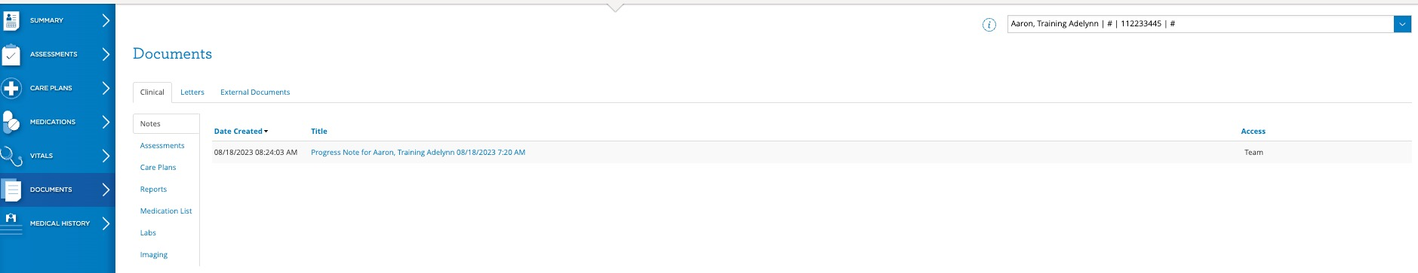

The Letters tab shows letters that have been previously generated and sent to a member.

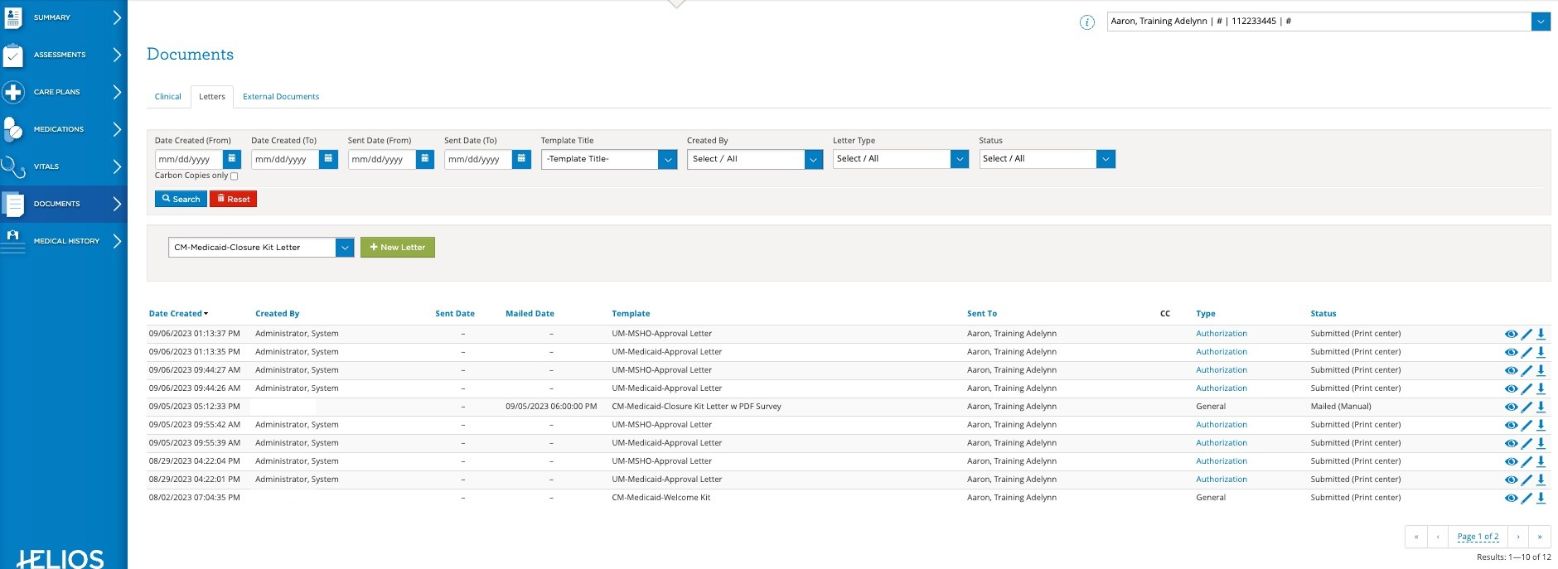

Medical History Tab

The elements of a medical history can encompass:

* Diagnoses
* Family History
* Visits, medical appointments or procedures that do NOT involve an overnight stay
* Admissions, overnight stays at hospitals or other medical facilities
* Procedures, surgeries or other physical interventions
* Immunizations
* Labs that have been administered (e.g., blood panel, urinalysis, etc.)
* Imaging diagnostic tests that have been administered (e.g., X-Ray, MRI, CT, etc.)
* Allergies, notable reactions to specific foods, drugs, or environmental stimuli
* Services, types of care not covered by the categories

Note: Most of this data is auto-populated on the basis of claims

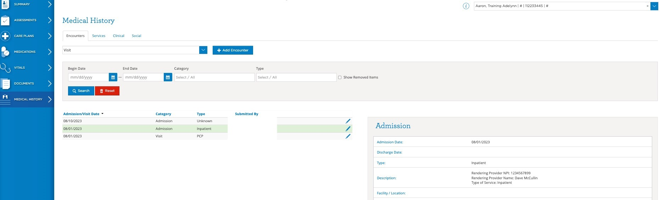

Each element in this section offers the user the opportunity to click on the element name which then prompts details of that element to populate to the right of the screen.

Navigating Between Member Records

Users can navigate to other member records by selecting the member’s name from the dropdown list appearing in the top, right corner of the screen.

