**How to Search for a member & view member specific information in HELIOS**

1. Navigating to Admin/Clients:
   1. Search member by name, DOB (Demographics tab), ID #, or other search field
   2. Using any of the search tabs (Identifiers/Coverage; Demographics; Records; Population; Additional)
   3. As you fill in the search fields they will show up cumulatively at the bottom
   4. Select “Search”
   5. Search results will show up at the very bottom

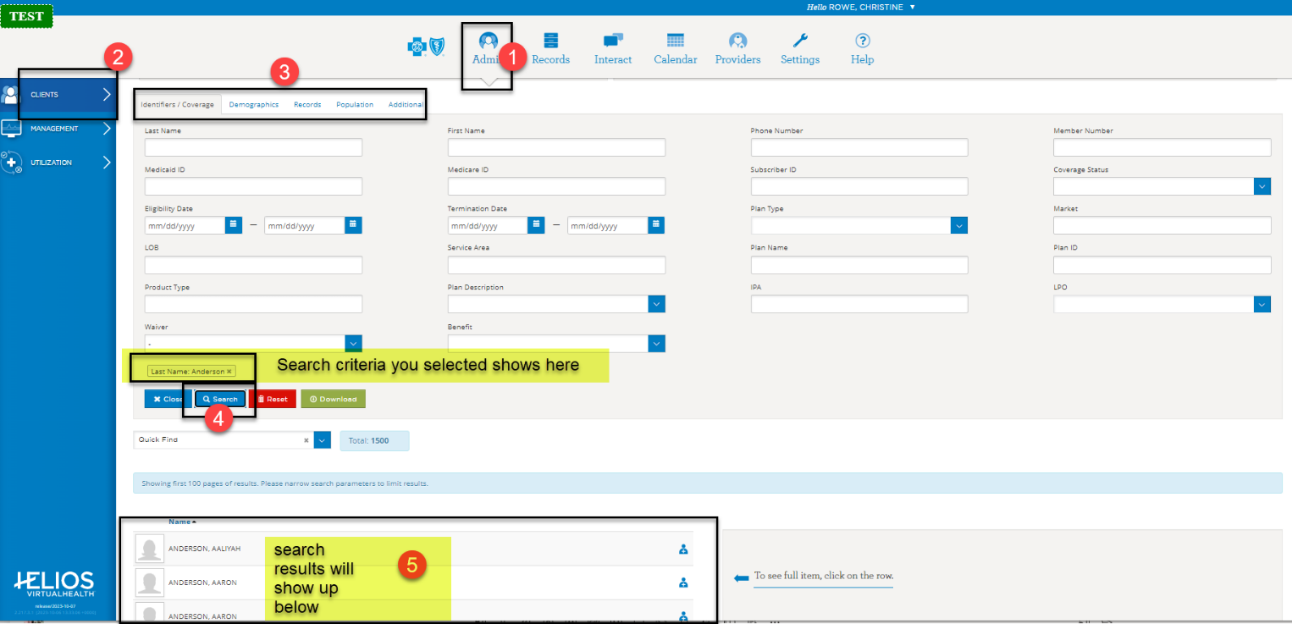

1. Find your member among the search results: Click the small blue head & shoulder icon with a small “+”
   1. Doing this adds this member to your “panel” so you can access all member records

3. Once you’ve added member to your panel, click the line to turn it green

* 1. Detailed member info pops up to the right side of the screen
     1. Here you will get shortcuts to key member areas
     2. Here you will see “Care team” if member has one

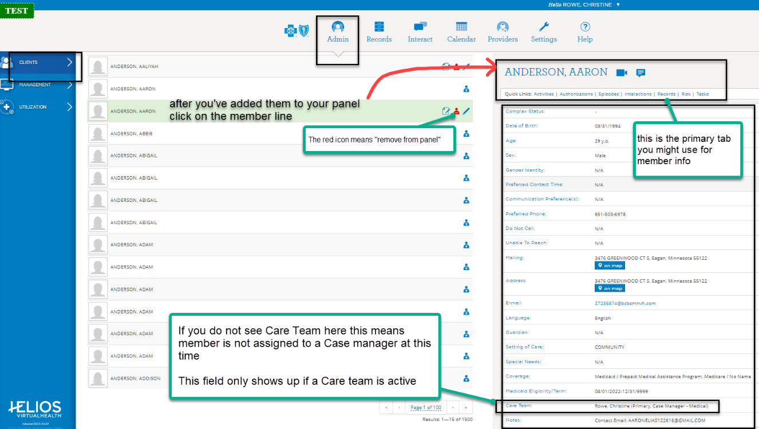

1. Select the “Records” hyperlink option (this will take you to the main screen where you can see Authorizations, Medications, Procedures, Admissions, Appeals info, etc.)

Removing a Member from your Panel

1. Navigate to Admin> Clients> Population
   1. User: enter your name
   2. On Panel: Yes
   3. Search
   4. Select the Red Icon “Remove from panel”

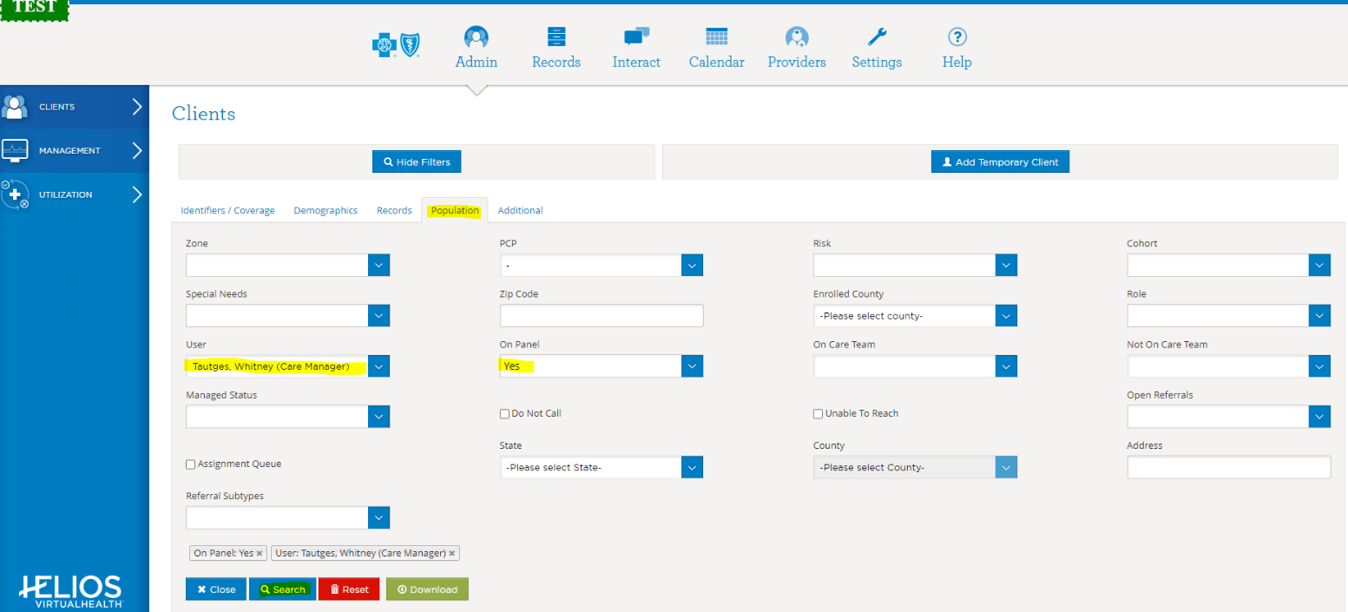



Clearing Search Filters

1. Remove individual search fields by selecting the grey x
2. To remove all search fields click the red “Reset” button

