Blue Plus created the attached Care Coordination Supplemental Benefits Q&A, which includes questions Delegates asked during Fall Training and questions that were posed during the 2024 Supplemental Benefits training.
2024 Supplemental Benefits Q&A
- This document has also been uploaded to the Training and the SecureBlue MSHO Supplemental Benefits pages of our Care Coordination website.
- If, after reviewing the Q&A, you have additional questions about 2024 Supplemental Benefits, please email your Partner Relations Consultant.

From the Training Page:

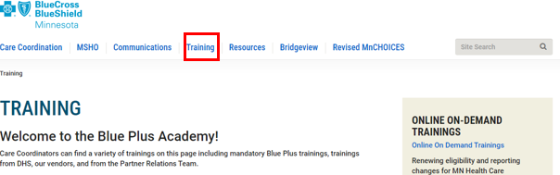

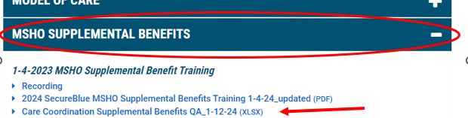

From the MSHO Supplemental Benefits Page:

