Title: SecureBlue Members Continue to be Eligible for In-Home and Virtual Wellness Assessments
In-home and Virtual Wellness assessment 2024
Signify Health

1-12-2024
Program Details: Blue Cross is continuing to offer in-home and virtual wellness assessments through vendor Signify Health in 2024 at no additional cost to our members. Members who sign-up will have an hour visit with a Minnesota licensed Nurse Practitioner or Doctor to discuss their ongoing health and wellness at home; check of blood pressure, heart rate, and reflexes; review their medications; check for in-home safety risks; discuss their medical history; and answer any health questions they may have. Additionally, members who choose the in-home assessment will have the opportunity to complete medically appropriate screenings and labs such as:
- Microalbumin kidney screening
- HBA1c screening
- Colorectal screening kit
- Osteoporosis bone scan
- Diabetic retinal eye exam
- Peripheral arterial disease screening
After the visit is complete, members will receive a recommended plan of care including appropriate referrals, a summary of what was discussed during the visit, and a satisfaction survey.
The visit summary and health assessment detailed report will be mailed to the member’s self-identified PCP. When the PCP receives the results, the office may wish to call their patient and schedule a visit to perform additional assessment as appropriate or schedule a follow up visit to address issues identified. If the member does not have a PCP this will be noted in their visit summary.
As a thank you for completing the In-Home or Virtual Wellness Assessment, members will receive one $25 Visa gift card that is good for food purchases at grocery stores and restaurants where Visa is accepted. The gift card will be mailed after the visit is complete and can take 4-6 weeks to be delivered. Signify is managing the gift card process through a third-party vendor.
As requested by many Care Coordinators, here are samples of Signify’s documents including:
- Sample no PHI Signify Questionnaire
- Sample Member Signify Post-visit handout
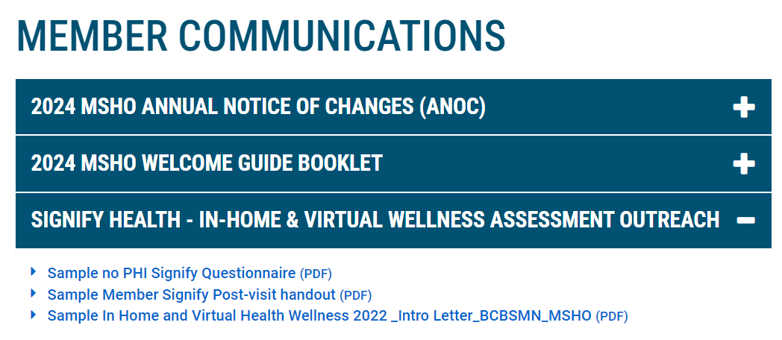

Targeted Population | We have identified approximately 6,000 SecureBlue members to receive targeted outreach via mail and phone outreach by Signify Health. Outreach will be on an ongoing basis through end of 2024. Members are identified for targeted outreach if they:  - Have an open risk gap or gap in care, such as needing to return to care with their PCP for an underlying condition or need an annual preventive care screening.  - Being referred by an BCBSMN member management entity such as Internal BCBSMN Case Management, Care Coordinators, Customer Service, Medication Management Therapy, or a Broker or Agent.  *** Only the above criteria will result in a member receiving the targeted outreach from Signify, however all SecureBlue members can participate by calling Signify Health at 1-844-226-8218 (TTY 711), 7 a.m. to 7 p.m., Central Time, Monday – Friday and 8 a.m. to 4:30 p.m., Central Time Saturday. Members may see the program advertised in Thrive, from a broker or care coordinator or on our website here: bluecrossmn.com/medicare-preventive
Program Goal | For Members: Blue Cross is committed to our members’ health and well-being. We want to provide members with the right care that is convenient to them.  For Business Purposes: To capture accurate risk diagnoses for risk adjustment submission.
Communication and Key Dates | Member introduction letters will be sent to targeted SecureBlue members beginning December 2023. Signify will begin phone engagement outreach on December 14, 2023 and this will continue throughout the year.  Members who schedule an appointment will receive an appointment reminder call via an intelligent voice response (IVR) 24-48 hours before their appointment.  Virtual Visits: 2-4 weeks after the visit is complete, the member will receive a recommended plan of care including appropriate referrals, a summary of what was discussed during the visit, and a satisfaction survey.  In-home Visits: 2-4 weeks after the visit is complete, the member will receive a satisfaction survey and lab results if labs were completed. Note: Members that have an In-home assessment will receive all their visit related documents at the time of the visit. The survey and lab results are the only mailed materials.  If performed, labs and preventative screening results will be mailed to the member 14 business days after the visit. Please note that preventative screening/lab tests will only be provided to members that have an identified risk gap for that specific condition. Not all members will receive the same screenings/labs. For members that are provided with the FOBT test (colorectal cancer screening kit), it will be their responsibility to mail the test after the visit.  3-4 weeks after the visit is complete, the member’s self-identified PCP will be mailed the visit summary and health assessment detailed report.  4-6 weeks after the visit is complete the member will receive a $25 gift card for completing their in-home or virtual assessment. (See below in gift card section for more details)
Member Referrals | Outbound to Signify:  BCBSMN team member warm transfers member to Signify Health or provides the member with Signify’s contact information to schedule an appointment. 1-844-226-8218 (TTY 711), 7 a.m. to 7 p.m., Central Time, Monday – Friday and 8 a.m. to 4:30 p.m., Central Time Saturday or they can visit schedule.signifyhealth.com.  Inbound to BCBSMN:  Urgent referrals are sent via secure email to BCBSMN Case Management within 24 business hours of the completed visit. Members may also be referred to emergency services (like a hospital). Some examples:  - Concerningly abnormal or dangerous biometrics (like high blood pressure)  - Abuse  - Severe mental health concerns  Social determinate of health referrals are sent to Internal BCBSMN Case Management within 7 days of completed visit. Some examples:  - Emotional health  - Food scarcity  - Falls risk  - Smoking cessation  - Weight management  - Transportation needs  - Financial assistance  - Urinary incontinence  All members are recommended to follow up with their primary care provider.
Gift Card Information | Members that complete an In-home or Virtual assessment are eligible for one $25 Visa gift card per year. The gift card is good for food purchases at grocery stores and restaurants. The gift card can take 4-6 weeks to receive after the visit. The gift card is sent by mail. There is no email option. Signify is managing the incentive process through a third-party vendor.  Members can contact Signify with gift card questions by calling them at 1-855-273-3531, 7 a.m. to 7 p.m., Central time Monday through Friday. TTY users call 711.  Members should be prepared with their first and last name, home address and phone number as identifiers when calling about their gift card. If the member needs to activate their gift card, they can go to myprepaidcenter.com to activate. The gift card cannot be used at an ATM and is not eligible for cash back.
Member Grievance Process | 1. Members can call Customer Service if they have a grievance with this initiative at 1-888-740-6013.
Contact | If a member has questions about the program or would like to schedule an appointment, direct them to Signify Health: 1-844-226-8218 (TTY 711), 7 a.m. to 7 p.m., Central Time, Monday – Friday and 8 a.m. to 4:30 p.m., Central Time Saturday. Members can also be directed to schedule.signifyhealth.com  Customer Service Representatives should assist members with additional questions they have regarding their plan's preventive care or annual wellness visit coverage. Members can also be directed to bluecrossmn.com/medicare-preventive to view information online. If there are internal questions, please contact Carrie Bell, carrie.bell@bluecrossmn.com.
FAQ | Q. Will the member be charged for services?  A. No, there is no cost to the member for this service. Additionally, no claim will be incurred for this visit and therefore it will not affect their annual preventive care benefits.  Q. How can a member opt out of the program?  A. 1. If a member is not interested in participating in this program, they can opt out of the calls/program by contacting Signify Health at 1-844-226-8218 and stating that they are not interested. Signify will take them off the outreach list.  A. 2. If a member doesn't want to be contacted for any program moving forward, they can be added to the Do Not Call list (DNC list). Please follow the below process:  - BCBS Customer Service rep send's email to StarsCoE@bluecrossmn.com and CC’s the Program Manager, Carrie Bell, carrie.bell@bluecrossmn.com containing the below info:  - Member's ID  - First and Last name  - Member's Date of Birth  StarsCoE adds member info to the Do Not Call list. The member will be removed from the call list 5-10 business days later.  Q. How does the in-home appointment work?  A. Members who choose the in-home option will be given a health questionnaire before the nurse practitioner or doctor enters their home.  Q. How does the virtual appointment work?  A. Members who choose to schedule the virtual wellness assessment will pick a day/time that works best for them. Effective 3/1/23, Signify will only be using a virtual platform called, Doximity. At the time of the appointment, the scheduled clinician will initiate the call by sending a text or email with a link to the member. The member will click the link to start the virtual visit.  Q. What if the member is having technical difficulties logging into their virtual visit?  The clinician will call the member via phone call before the visit starts to make sure the member is ready for the virtual visit. The clinician will then send the member a text or email with a link to login to the visit. If the member is having issues logging in to the link, the clinician will help the member troubleshoot the issue.

