Dear Care Coordination Partners,
MSHO & MSC+ Guidelines Updates

The MSHO/MSC+ Care Coordination Guidelines were updated and posted to our Care Coordination website. The changes made to the guidelines are in red font accessible via clicking on the red sections in the Table of Contents and throughout the documents to make it easier to review.

The following sections and/or sub-sections have updates:

Community Guidelines
- Contact Information: removed and replaced with the link to our Blue Plus MSHO MSC+ Key Contacts resource.
- Definitions
- New: Summary of Requirements & Timelines (at-a-glance grids by living arrangement)
  - Also created separate At-A-Glance resource located on the website under Community Guidelines
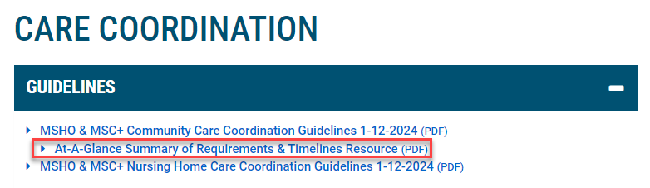
- New Model of Care/process change: An update has been made to our Model of Care allowing mid-year visits for EW members to be completed telephonically. See Mid-Year Contact Requirements: Elderly Waiver & Community Well members section for guidance.
- New: Elderly Waiver Remote Assessments
- Entry of LTC Screening Document information into MMIS
- PCA Authorization Processes

- EW Specialized Equipment and Supplies (T2029): This section removed. Guidance for this process is now incorporated into a new stand-alone document: EW T2029 DME Payor Determination Guidelines and Checklist 1-8-2024. This document and an updated T2029 Guide has been moved from the Bridgeview page to the Care Coordination page of the website. See below.
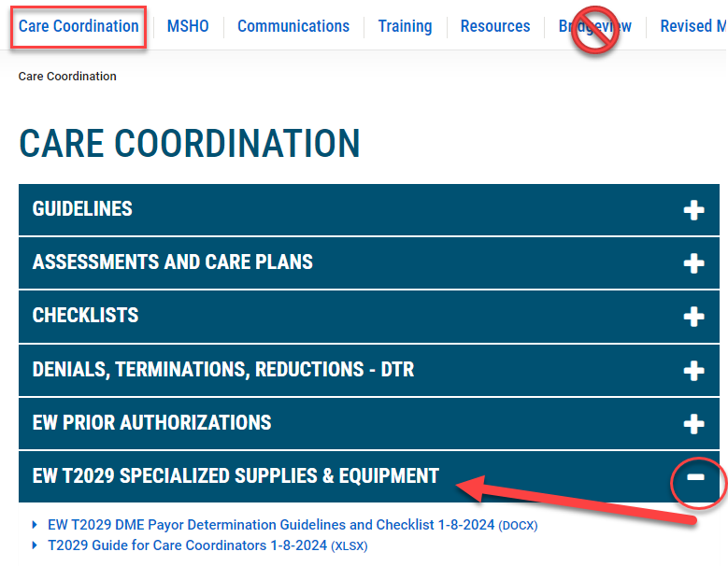
- Authorization Process for Lift Chairs
- Transitions of Care (TOC)
- New: Transfers after disenrollment
- 90 Day Grace Period (MSHO only)

Nursing Home Guidelines
- Contact Information: removed and replaced with the link to our Blue Plus MSHO MSC+ Key Contacts resource.
- Definitions
- Blue Plus members living in a Veteran Administration Nursing Home
- Nursing Home/ICF Product Change
- New: Transfers after disenrollment

If you have any questions, please contact your Partner Relations Consultant.

