Instructions for Clearing your Cache

Caution: If you are using the Revised MnCHOICES application and have checked out assessments/support plans, do not clear your cache until you have checked in your Revised MnCHOICES assessment/support plan information back online. If you have assessments/support plans checked out and you clear your cache, you will lose that information and will not be able to retrieve it.

If you are experiencing issues with accessing and/or the proper functionality of Bridgeview, try clearing your web browser’s cache.

Tips:
- Use Google Chrome or Microsoft Edge to access Bridgeview (do not use Firefox or Internet Explorer)
- After clearing your cache, log out of Bridgeview and log back in

- Select the three ellipses at the top right corner of your browser screen
- Select “More Tools”
- Select Clear Browsing Data
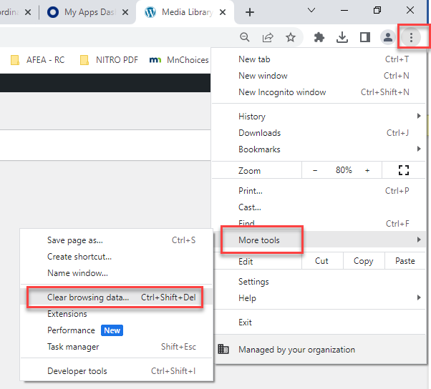
- Click on Clear browing data
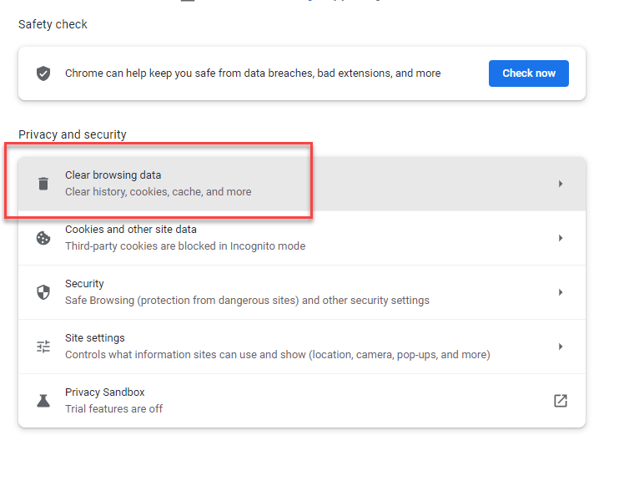
- Unselect browsing history
- Select Cookies and other site data
- Select Cached images and files
- Click on “Clear Data”
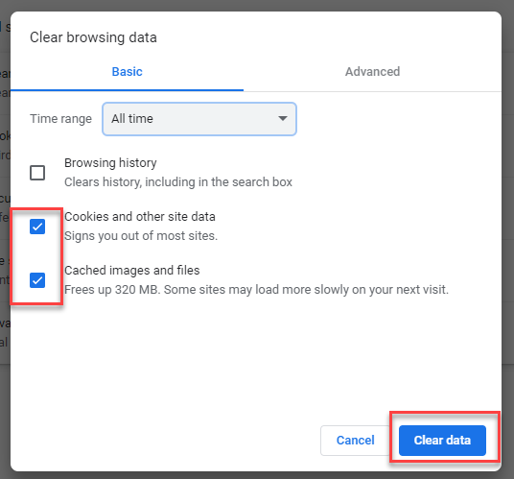

Users may contact the BCBSMN Help Desk at 1.800.333.1758 or reach out to their internal IT support staff to get assistance with clearing your cache.

Please contact your Partner Relations Consultant if you have any questions.

