**Blue Plus/Bridgeview HRA Audit Tip Sheet:**

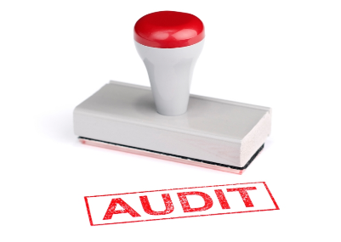

[This Photo](http://lawyersandsettlements.com/blog/tag/government-fda-audit) by Unknown Author is licensed under [CC BY-ND](https://creativecommons.org/licenses/by-nd/3.0/)

**Please refer to the** [**BV Care Coordinator Guide**](https://carecoordination.bluecrossmn.com/wp-content/uploads/2022/12/Bridgeview-Care-Coordination-User-Guide-11-3-2022_.pdf) **for complete instructions on entering assessments in Bridgeview.**

**IMPORTANT:** Our automated system can only accept one attachment via email. Attachments must be submitted in PDF format. If you are providing more than one document per member, you must combine them into one PDF document before attaching them to the email. For example, if you are supplying contact notes and an Unable to Contact Letter, combine them as one PDF and attach to the email.

|  |
| --- |
| **Completed Assessments (documents/dates requested)** |

**\*\*Enter the date of the assessment (we have included a screenshot below of the date we are requesting per type of HRA form used):**

* **LTCC:** Long-Term Care Consultation Form DHS 3428 (or DHS3428A)

* **6.15 Nursing Home Assessment:** Used for members residing in the nursing facility or Intermediate Care Facility (ICF) Table

  Description automatically generated
* **6.28 Transitional HRA:**

* **Fee for Service:** the MnCHOICES, LTCC or 3428H assessment that was completed prior to enrollment with Blue Plus. Please enter the date from the prior assessment in Bridgeview.

* **6.28.01 Nursing Home Transitional HRA for Product Change:**

* **DHS 3428H:** (For face-to-face assessment, telephonic assessments for CW members who choose not to complete an LTCC; and assessments for members on another waiver)

|  |
| --- |
| **Unable to Reach** |

* In Bridgeview, choose **No Form and Unable to Reach**
* There must be a total of **4 contact attempts** with the final attempt being mailing of the 8.40 Unable to Contact letter.
* **Enter the date on the final letter in the Assessment date field and the Letter sent field** in Bridgeview. **The Assessment Date and the Letter Sent dates should be the same.**

* If the member does not have a contact number, other forms of outreach to locate working phone number may be counted as contact attempts.
* Make sure your case note dates match the three contact attempt dates listed in Bridgeview.
* Submit case notes/letters showing the 3 missed contact attempts and the first page of each Unable to Reach letter that was sent. **A letter must be the final 4th contact attempt.**

|  |
| --- |
| **Refusals** |

* In Bridgeview, choose **No Form and Refusal**
* Enter the date of the refusal in Bridgeview.
* Submit your dated note showing member’s refusal to complete the assessment.
* **\*\*Nursing home members cannot be entered as a refusal**

|  |
| --- |
| **HRA Audit Errors** |

* **If you receive an email notifying you of a failed audit, you can log into Bridgeview to view the notes explaining the reason for the failure. See example below:**

* **Click on Comments to see explanation of HRA audit failure:**

