August 28, 2020

Dear Care Coordination Partners,

This communication is to provide additional MnSP EW RS Tool training resources and supports on how to add/edit users, reset passwords and next steps to navigate MnSP post MnSP EW RS Tool launch that occurred on August 3rd.

**MnSP EW RS Tool User Access:**

* Verify brand new MnSP users (included on the RS Onboarding Tool form who completed their required Handling MN Information Securely training) received their 2-part emails from DHS. If users have not received these emails, please instruct users to search their spam folder for an email from [NO-REPLY-MNSP@STATE.MN.US](mailto:NO-REPLY-MNSP@STATE.MN.US). User ID’s are included in the RS Onboarding Form. If users have not received the email with their temporary password, please send a detailed email with the users information to[Partner.Relations@bluecrossmn.com](mailto:Partner.Relations@bluecrossmn.com) for further research.
* Existing MnSP users did not receive a 2-part email from DHS. These users will use their existing User ID and password to log in.

All Users are highly encouraged to log into the [MnSP production site](https://mnch-supplan.dhs.state.mn.us/) to confirm their Blue Plus MnSP combination was set up correctly.

**Instructions for Add/Edit User or Password Assistance:**

1. **Adding New/Reactivate User to MnSP EW RS Tool:**

High Importance: Upon user successfully logging onto [Handling MN Information Securely](https://data-securitytraining.dhs.mn.gov/Account/Login), go to settings to ensure the User training role is set to ‘County Worker’. This step is necessary to generate the appropriate courses to enable access to MnSP. If user does not have an account, registration is required.

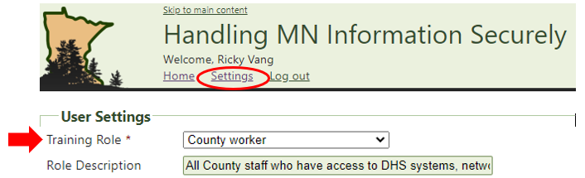

*User must complete all of the required Handling MN Information Securely courses under the training role ‘County Worker’ prior to Supervisor/Manager submitting the form to request new MnSP user access to [Partner.Relations@bluecrossmn.com](mailto:Partner.Relations@bluecrossmn.com.Assessment). Required training assessment completion dates must be included on the request form for all new user requests.

*This is a temporary process until DHS implements Remedy on Demand (RoD) for submitting these requests.* The Supervisor/Manager will complete the following fields on the **MnCHOICES Support Plan Request and Authorization form** and return it to [Partner.Relations@bluecrossmn.com](mailto:Partner.Relations@bluecrossmn.com). See attached form for future requests. Incomplete forms will not be processed:

* + Requestor Information section: will be prepopulated with the Blue Plus Security Liaison’s information
  + Action to Take for User Maintenance section: Supervisor/Manager will select the appropriate action being requested (brand new access = “New User” vs. adding BP combination to existing MnSP access = “Add an Agency/Agency Combination to User”, “Reactivate”, etc.)
* How the access will be used section: will be pre-populated with MnSP EW RS Tool Access
* Action to take for Team Maintenance section – leave blank
* Action to take for Agency Maintenance section – leave blank
* Training section: Supervisor/Manager must enter training assessment completion dates for required trainings (training role must be “County Worker”)
* Submit section – leave blank

Next Step: if the User has not already reviewed the trainings in TrainLink related to EW RS Tool it is highly recommended.  [MnCHOICES County Link](https://www.dhs.state.mn.us/main/idcplg?IdcService=GET_DYNAMIC_CONVERSION&RevisionSelectionMethod=LatestReleased&dDocName=DHS-319870) has a list of relevant EW RS Tool courses.

1. **User edit/deactivate requests:**

Send edit requests by email to [Partner.Relations@bluecrossmn.com](mailto:Partner.Relations@bluecrossmn.com)

Email must include the following:

* User’s full name, must include middle initial. If no middle initial, indicate “none” (if name change must indicate previous and new name)
* User ID
* Reason for the edit request (i.e., name change, update contact info, wrong ID, deactivate access and date, etc.)

1. **User password assistance requests: (reset/unlock)**

Contact the Blue Cross Help Desk 1-800-333-1758. Callers must have their User ID available for verification.

**\*Call to Action:** The Blue Cross Help Desk requires callers to verify their User ID for password assistance. It is important for this information is accurate.

Attached you will find the RS Onboarding Form to verify accuracy of all User ID’s and Care Coordination contact information. If new users on the list have not received their temporary password, please send a detailed email with the users information to[Partner.Relations@bluecrossmn.com](mailto:Partner.Relations@bluecrossmn.com) for further research.

For future new users, Delegates are responsible to provide newly assigned User ID’s to Blue Plus ongoing by emailing [Partner.Relation@bluecrossmn.com](mailto:Partner.Relation@bluecrossmn.com).

**Training Resources:**

* [TrainLink](https://urldefense.com/v3/__http:/www.dhs.state.mn.us/main/idcplg?IdcService=GET_DYNAMIC_CONVERSION&RevisionSelectionMethod=LatestReleased&dDocName=training__;!!CwIvYz4dIaSa!dmXZwwopEjPyWEsS3-QTq8pydyiJ-uqLcCQzBS2BVJS4xw-RkyrfT1zaRTTPbyFjrj9h$) (link to register for DHS trainings related to MnSP)
* Archived MnSP EW RS Tool Launch trainings can be accessed at [DSD Training Archive](https://urldefense.com/v3/__http:/www.dhs.state.mn.us/main/idcplg?IdcService=GET_DYNAMIC_CONVERSION&RevisionSelectionMethod=LatestReleased&dDocName=dhs16_143138__;!!CwIvYz4dIaSa!dmXZwwopEjPyWEsS3-QTq8pydyiJ-uqLcCQzBS2BVJS4xw-RkyrfT1zaRTTPb_wwOoXo$) (reminder audio is only available for 3 months)

* [Handling MN Information Securely training Login](https://data-securitytraining.dhs.mn.gov/Account/Login)
* [MnSP training module exercises](https://www.dhs.state.mn.us/main/idcplg?IdcService=GET_DYNAMIC_CONVERSION&RevisionSelectionMethod=LatestReleased&dDocName=dhs-319870)

Recommended training upon successful log in to Train Link:

* **For new users to MnSP**, search and select the course MNSP1000. The ‘Course Content’ tab within MnSP1000 contains the list of Support Plan training modules.
* **For people who have previously enrolled in MNSP1000:** search and select MnSP1001 to take the RS Tool training modules.

**Care Coordinators may use a virtual environment to work within the training zone** using this link [MTZ-SP](https://mnch-supplan-train.dhs.state.mn.us/login.aspx).Use the list of *test* user names and passwords provided to your agency prior to launch. Please reach out to [Partner.Relations@bluecrossmn.com](mailto:Partner.Relations@bluecrossmn.com) if you need this information to be resent.

On the MTZ-SP login page you will:

* + - * Choose Blue Plus from the “My Agency” login drop down menu
      * Enter the test User ID and PW assigned

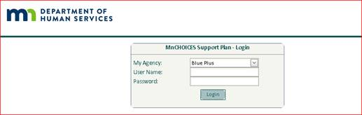

**Important Reminders:**

* The RS Tool excel workbook is no longer available and the MnSP EW RS Tool should be used for new tools and tool changes as of August 3rd, 2020.
* EW RS Tools should be moved into “closed” status upon final completion
* Unable to locate a member in the MnSP application: log out and return the next day to search for the member. If the member is still not in the MnSP application, the User will follow instructions for MCO’s and complete the “[MCO Tool to add a person to the MnCHOICES database](https://surveys.dhs.state.mn.us/snapwebhost/s.asp?k=164564970375)” found on the [MnCHOICES CountyLink Support Plan](https://www.dhs.mn.gov/main/idcplg?IdcService=GET_DYNAMIC_CONVERSION&RevisionSelectionMethod=LatestReleased&dDocName=DHS-289286) page
* Passwords become inactive after 90 days of inactivity. When this occurs contact the Blue Cross Help Desk 1-800-333-1758 for a password reset.
* For technical issues or concerns, first refer to the MnCHOICES CountyLink [*Known Issues*](https://www.dhs.state.mn.us/main/idcplg?IdcService=GET_DYNAMIC_CONVERSION&RevisionSelectionMethod=LatestReleased&dDocName=dhs-308283) *and* [*Trouble Shooting Documents*](https://www.dhs.state.mn.us/main/idcplg?IdcService=GET_DYNAMIC_CONVERSION&RevisionSelectionMethod=LatestReleased&dDocName=dhs-289285). If unable to resolve, complete the DHS 6979 MnCHOICES Help Desk Contact Form. Choose EW Residential Services Rates for question type.
* DHS will generate notifications when MnSP has outages, users should wait until they receive the “All Clear” notification prior to accessing the application. It is important to note that the URL’s for the production and test site are subject to change with updates. Browser cache may need to be cleared after outages. [MnCHOICES scheduled outages link](https://www.dhs.state.mn.us/main/idcplg?IdcService=GET_DYNAMIC_CONVERSION&RevisionSelectionMethod=LatestReleased&dDocName=DHS-339002).
* Optional DHS EW RS Tool post launch calls:

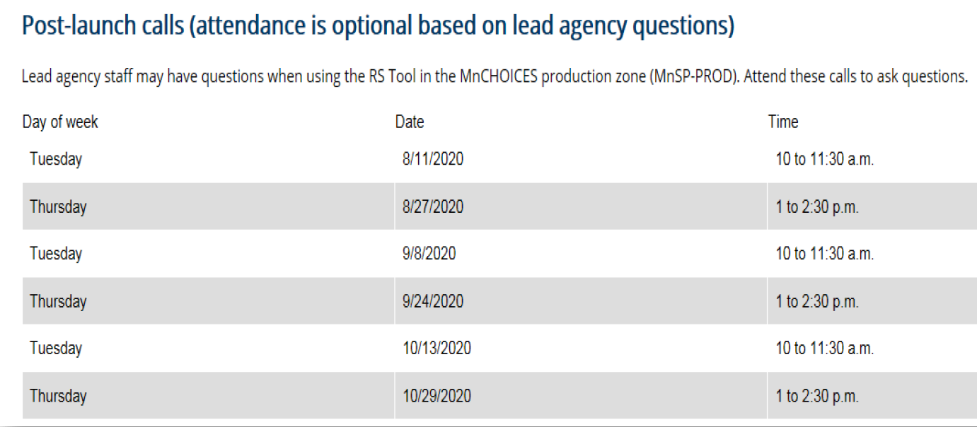

Please reach out to [Partner.Relations@bluecrossmn.com](mailto:Partner.Relations@bluecrossmn.com) if you have any questions.

**Partner Relations Team | Government Markets**

[Partner.Relations@bluecrossmn.com](mailto:Partner.Relations@bluecrossmn.com)

Stormy Church, Manager

Consultants:  Melinda Heaser   | Kim Pirkl   | Nissa Roberts   | Ricky Vang | Kim Flom-Brooks