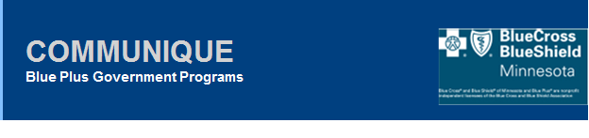

September 2nd, 2021

Dear Care Coordination Partners & MnCHOICES Mentors,

The purpose of this communique is to provide clarification and updates to communications recently sent regarding the Revised MnCHOICES Onboarding sheet/launch and MnCAT Trainings.

**Training for MCO Lead Agencies**:

*All Care Coordinators must have their MnCAT training (located in* [*TrainLink*](https://www.dhs.state.mn.us/main/idcplg?IdcService=GET_DYNAMIC_CONVERSION&RevisionSelectionMethod=LatestReleased&dDocName=Training)*) prior to the scheduled Revised MnCHOICES launch on 11/1/2021 (*MnCAT step 3 has 3 parts). Staff that have not completed their required MnCAT Trainings will be loaded with the initial onboarding but will not have access to the revised MnCHOICES until all their trainings are completed.

Please review the updated DHS page for additional training details [Review MnCHOICES application: MnCHOICES Certified Assessor Training (MnCAT) process](https://www.dhs.state.mn.us/main/idcplg?IdcService=GET_DYNAMIC_CONVERSION&RevisionSelectionMethod=LatestReleased&dDocName=dhs-329820).

*The DHS secret link will be provided in the body of the email accompanying this communique.

***Reminder: Users must be logged out of TrainLink prior to clicking on the secret URL link for MnCAT step 3 to work, otherwise you will get a “spinning” icon on your screen.***

**Revised MnCHOICES Onboarding sheet clarifications**:

At a minimum, each staff listed on the Blue Plus Onboarding sheet must have all their required [Handling MN Information Securely](https://data-securitytraining.dhs.mn.gov/Account/Login) training completed otherwise they will NOT be loaded.

* Verify the correct training role is selected. Review *Settings*, it can be County Worker or MCO Contractor/Delegate Worker. DHS provided new guidance, going forward we may now choose MCO Contractor/Delegate Worker now instead of County Worker. Both have the required minimal trainings.)

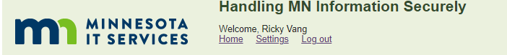

* Only include information for staff that will be working with Blue Plus (i.e., Care Coordinator working with 2 other health plans but not Blue Plus, do not add this staff to the Blue Plus Onboarding sheet)
* Staff listed on the Onboarding sheet that have “Y” selected for “Needs_Access” but does not have their Handling MN Information Securely training completed will not be loaded. This will require a manual add later.
* Staff listed on the Onboarding sheet that have “Y” selected for “Needs_Access”, has their required Handling MN Information Securely training complete, but does not have all their required MnCAT training completed will be loaded however, will not have access to MnCHOICES until their required MnCAT training is completed.
* For all Blue Plus Care Coordinators, regardless of where they are with their MnCAT training:
  + Select “Y” to “Needs_Access”
  + Select “Y” to “Certified_Assessors”
  + Select “Y” to “Staff_Role_CC_MSHO-MSC”
  + Include their TrainLink ID (DHS will monitor nightly and grant access when all required MnCAT Trainings are completed and verified)

**Additional DHS Resources for Mentors:**

* [MnCHOICES Matters](https://www.dhs.state.mn.us/main/idcplg?IdcService=GET_DYNAMIC_CONVERSION&RevisionSelectionMethod=LatestReleased&dDocName=DHS-289290) Newsletters
* [MnCHOICES Revision Project page](https://www.dhs.state.mn.us/main/idcplg?IdcService=GET_DYNAMIC_CONVERSION&RevisionSelectionMethod=LatestReleased&dDocName=DHS-328289) (review launch webinar schedule, upcoming 9/15/2021)
* [Revised MnCHOICES staff training email](https://www.dhs.state.mn.us/main/idcplg?IdcService=GET_DYNAMIC_CONVERSION&RevisionSelectionMethod=LatestReleased&dDocName=dhs-330184)
* [Revised MnCHOICES application: MnCHOICES Assessment Training Instructions](https://www.dhs.state.mn.us/main/idcplg?IdcService=GET_DYNAMIC_CONVERSION&RevisionSelectionMethod=LatestReleased&dDocName=dhs-330139)

* [MnCHOICES Training Zone (MTZ) URL](https://minnesota-trn-release-proxy.feisystems.com/) (User ID’s were previously provided, the password will be provided in the body of the email accompanying this communique)

DHS Timeline: Please return your Blue Plus onboarding sheet back to your PR Consultant by September 10th.

If you have any questions, please reach out to your Partner Relations Consultant.

Thank you,

**Partner Relations Team | Government Markets**

[Partner.Relations@bluecrossmn.com](mailto:Partner.Relations@bluecrossmn.com)